City & County of San Francisco
CCSF 2013 NAVD88 Vertical Datum (SFVD13)
Precise Leveling Specification and Procedures
Prepared January 2013, Revised September 8, 2016

PURPOSE: The City and County of San Francisco (CCSF) performed a differential leveling survey to recover the North American Vertical Datum 1988 (NAVD88) orthometric heights (elevations) and establish a precise leveling network in the City and County of San Francisco in 2013. These Specification and Procedures were adhered to for the 2013 survey and will be used on future precise leveling surveys. The results are published in the document titled “SF Vertical Datum of 2013 (SFVD13) Benchmark List - NAVD88 Orthometric Heights as Recovered by CCSF in 2013”

SURVEY: The original leveling was performed between January and October 2013. The leveling survey contains 22 loops totaling 72 miles. There are five Primary Loops designated Loops A through E shown below. The remaining secondary loops provide connections to the CCSF 2013 High Precision Network Control Points (CCSF HPN) (points 101-120). The loops were designed based on the location of NAVD88 Benchmarks, the location of the HPN Control Points, route safety and survey expediency. New benchmarks were set approximately 300-700 feet apart along the leveling routes. The network was densified with an additional 71 miles of leveling in 2014-2015.

DATUM RECOVERY: National Geodetic Survey (NGS) NAVD88 First Order Benchmarks were included in the 2013 survey to recover the NAVD88 Datum in the CCSF. All Benchmarks listed as “Adjusted” in the NGS Datasheets with a stability designation of A or B on a scale of A through D were included for this purpose. Loops A and B recovered NGS Benchmarks located along Highway 1 from the south side of the County northerly to Highway 101, and easterly along the shore of San Francisco Bay to the Bay Bridge. Other Benchmarks exist but derive their NAVD88 Heights from a VertCon shift and are not suitably accurate for the purpose of this survey. NGS HPGN Stations and 1999-2002 City Precise Leveling Survey Benchmarks were included when encountered along the routes. NAVD88 Benchmarks determined by “Vertcon” exist in the City and were included when encountered along level routes but were not used for the Datum recovery.

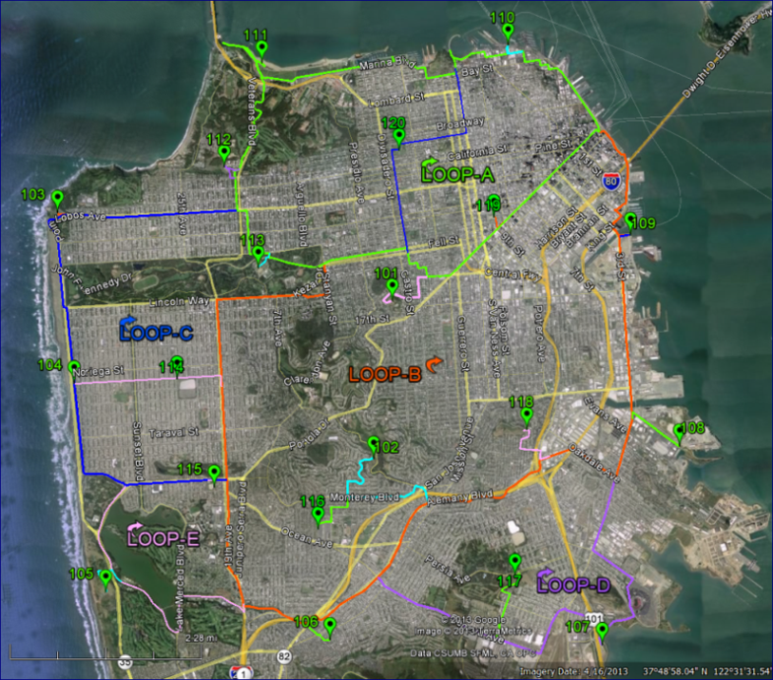
2013 Primary Level Network and High Precision Network Points
TECHNICAL REQUIREMENTS

Field Requirements

A schedule and plan for executing the field work must be prepared prior to beginning the work.

All leveling measurements are collected electronically in the field in metric units to 0.0001 meters. Hand written field notes are kept to document the survey and include the date, crew member names, instrument model/serial number, rod model/serial number, morning calibration, crew member assignments, general description of the route, names of benchmarks and their aliases with the measured and published elevations, the field error of closures, and weather conditions during the survey (temperature, clear, overcast, rain, wind, heat waves etc. Note any problems encountered and any other information a surveyor would deem to be important in the evaluation of the accuracy of the level run. The field notes will record the turning points and benchmarks with brief comments. The rod heights and distance measurements are recorded electronically. The job names containing the leveling data in the instrument are cross-referenced in the field notes.

The temporary turning points are assigned a unique sequential numerical ID, not to be repeated in subsequent Lines. Verify the next available turning point number prior to starting a survey. New benchmarks are assigned an alpha-numeric ID. The ID number range for benchmarks are limited to 10001 and 15999. In 2013-2015 benchmarks were assigned ID’s that began with “BM10001”, “BM11001” and BM13000+. The replacement of destroyed benchmarks began in August 2016 with number 12001. Verify the next available benchmark ID number prior to starting a survey. NGS Benchmarks ID’s are modified by replacing the two alpha character in the NGS PID with “BM99”. For example, HT0687 was named “BM990687”. Leading alpha characters in a name are necessary for identifying benchmarks in the Starnet Adjustment “*.dat” file discussed below. Elevation differences are accumulated through points with numerical only ID’s and the sum of the differences between alpha-numeric ID’s is reported in the output.

When initiating or closing a level loop, two or more benchmarks in the previous loops are included and must be in agreement by 0.0003 meters (0.001 feet).

Level and Rod Instruments

The level instrument presently in use is the Leica DNA10 level. The instrument should be in excellent condition and calibrated by Leica annually.

The level is checked for collimation error (peg test) using the “AxBx” method and adjusted if necessary each morning of operation. The adjustment results are stored in the instrument and the results are recorded into the survey notes. Use the following file naming conventions: If the first calibration occurred on January 2, 2013 which is day 2 of the year, then name the calibration job file “D002CAL1”.

If the Collimation error is found to be greater than 5 seconds (∆ difference), then store the collimation results and perfume the test again. If again the collimation test resulted in a greater than 5 second (∆ difference), then refer to the project coordinator for an assessment and decision on whether to continue.

A standard fixed length leg leveling tripod is preferred.

The leveling rods are three piece 13.3’ Leica barcode rods. Unless surveying through hilly terrain with large elevation differences, it is preferred to level with only two sections of the rod. The rods must be in good condition, with minimal scratches on the face of the bar code. All leveling rods have a unique number that facilitates tracking the leveling rod in the surveys.

The leveling rods have a level bubble for plumbing. Rod plumb is checked each day during the instrument collimation test by aligning the vertical cross hair with the edge of the rod facing the instrument and turned at 90 degrees and noted in the field book.

The rod seams are calibrated periodically and must check 0.0003 meters (0.001 feet). A Rod Seam Calibration field note form is provided for this purpose (see example below):

Data Management Requirements and Reporting

Memory in the DNA10 is limited to 16 jobs and Job names are limited to 8 characters. Press MENU, 3 on the DNA10 to see the number of jobs available. All jobs are transferred to the memory card and to an off instrument backup location daily and before deleting jobs.

Measurements collected in the field are stored by “Lines” in job files. For example, in 2013 the first leveled Line Loop “A” on January 2 named "D002ALO1". The naming convention follows: Based on the Julian calendar, January 2, 2013 is day 2 of the year (D002). The fifth character refers to the loop or route name. In this case we are referring to Loop “A". Subsequent routes use B, C, D… AA, AB etc. The last 3 digits refer to the Line number “L01”. In the 2014-15 densification leveling surveys, the route identifications extended beyond “Z” to AA, AB, AC etc. To accommodate this, the job name was changed to “002AA1L1” for example. In August 2016, the effort began to replace destroyed benchmarks with minor loops/sections that started and ended on two or more existing benchmarks. The section or loop name was changed to “266W-011” or “266AW011” for example where the W- or WA is the original loop/section, the 01 in the 6th and 7th place is the loop number and the 8th digit is the line number.

Digital leveling data contained in each job is to be exported each day in three available formats. First, export a “GSI-8” Leica ASCII output file named “*.gsi” containing the raw digital measurements (see an example at the end of this document). Second, export a file named “*.dat” which is a Digital Level Measurement Report listing an electronically generated summary of the turning points and sight balance distances. This file must be re-name from “*.dat” to “*.txt” to avoid conflicts with the Starnet .dat files). Last, export a file named “*.dax” which is a Digital Level Measurement Report in a conventional field book form of the leveling survey.

The “*.gsi” files are converted with the Starnet Converter Application to a Star*Net Pro file named “*.dat”. These files contain the measured elevation differences between points with alpha prefixes. If the GSI file is edited to correct errors in the field prior to the conversion, then it is indicated in the file name as “*-EDIT.gsi” and saved with the original unedited GSI file.

The *.dat files are compiled and adjusted in Star*Net Pro or Star*Lev software.

The field notes serve as a daily project report of each day’s progress, files produced, problems encountered and changes from the work plan. Noting communication between the field crews and office, for clarifications or help with issues that arose during the survey are essential.

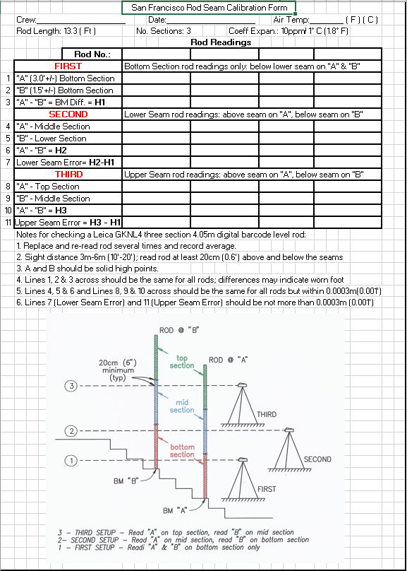

Leveling Procedures

This section serves to outline the methods used to maintain leveling accuracy with electronic leveling instrument and barcode rods. It is the intent to follow the FGCS Vertical v4.1 Specifications for Second Order Class 1 as outlined below.

Two rods are observed using the Backsight-Foresight-Foresight-Backsight (BFFB) method. The rods are moved forward in a leapfrog fashion. A minimum of three readings are made for each sight with a standard deviation of 0.3 mm (0.0003m=0.001 feet) or less.

Leveling closures are required to meet Federal Geodetic Control Subcommittee (FGCS) Second Order Class 1 which allows for closures of 6 mm√km per loop or section. However, the expectation based on extensive experience is the closure will be 3 mm√km per loop or section

Turning plates (“Turtles”) are used along with other stable points, such as nails, spikes, definite high points on solid objects, etc. Turning points are marked for recovery during the survey. When turtles are used they are placed on solid level ground and stepped on with the full weight of the rod person for a count of three before taking the rod reading.

The backsight and foresight distances are generally kept to 50 meters or less but do not exceed 60 meters. Backsights and foresights must be balanced to within five (5) meters and loops or sections must be balanced within 10 meters.

Minimum ground clearance for the line of sight is 0.5 meters (1.5’) if the length of sight is greater than 16 meters (52’). If less than 16 meters, clearance must be 0.3 meters (1’). The rod must not be read within 30cm (1’) of the top or bottom of the rod. The DNA10 is set up to warn the operator in this event.

No side shots are allowed. All benchmarks/permanent monuments must be turned through and included in the loop or section.

Leveling is to be avoided in heat waves, rain and windy conditions. If the 0.0003 meter (0.001 feet) standard deviation cannot be consistently met then leveling is discontinued.

Leveling across road bridges required special care and is avoided when possible. If necessary, the rod and instrument are located over support structures to minimize bridge sway and flex from passing vehicles.

Leveling Validation Demonstration Survey

Before initiating the leveling survey, a “demonstration” survey is required of each crew to validate their assigned equipment is operating correctly and the crew understands this “Leveling Specification and Procedures”. A collimation test is to be performed prior to the demonstration surveying. A demonstration and validation site of six permanent points is located at the Civic Center. The closure must meet the tolerances noted herein. The results will be downloaded, processed and documented to validate that the crew, instruments and procedures are worked properly.

Example of a Leica coded GSI File
-------------------------------------------------------------------------------------
410001+?......1
110002+00000082 83..51+00000000
110003+00000082 32...1+00023956 331.21+00005763 390...+00000002 391.21+00000000
110004+0000C109 32...1+00010940 333.21+00005462 390...+00000002 391.21+00000000
110005+0000C109 83..21+00000301
110006+00000MW9 32...1+00037687 333.21+00006386 390...+00000002 391.21+00000000
110007+00000MW9 83..21-00000623
110008+0000MWG9 32...1+00037823 333.21+00005520 390...+00000002 391.21+00000000
[gap]
110066+00VW11BG 32...1+00099041 333.21+00005747 390...+00000002 391.21+00000000
110067+00VW11BG 83..21-00000139
110068+000C4000 32...1+00051040 332.21+00004806 390...+00000002 391.21+00000000
110069+000C4000 573..1+00043702 574..1+01070328 83..21+00000803

Example of a .LEV “Digital Level Measurement Report” File using the BFFB Method
-------------------------------------------------------------------------------------
Leica Geosystems AG --- Digital Level Measurement Report
-------------------------------------------------------------------------------------
Job name : D002AL01
-------------------------------------------------------------------------------------
Operator : JTM
DNA10 : Instr.Nr.: 337159
Remarks : INT #1 / --------
Date/Time : 28.12.2012 / 9:26: 8 -------------------------------------------------------------------------------------
Line Leveling
-------------------------------------------------------------------------------------
Line : D002AL01 Method: BFFB
=====================================================================================
Date : 02.01.2013 Time : 09:49:28
Staff1: GP2 Staff2: PC1
=====================================================================================
¦ PointID ¦Backsight ¦Foresight ¦ ¦ ¦ Distance ¦ Remarks ¦
¦(Station Result)¦ (B1-B2) ¦ (F1-F2) ¦(St Diff) ¦(delta H) ¦ (D Bal ) ¦ (Pt Hgt ) ¦
-------------------------------------------------------------------------------------
¦Start PtID ¦ ¦ ¦ ¦ ¦ ¦ ¦
¦BM990687 ¦ ¦ ¦ ¦ ¦ ¦( 3.7790)¦
¦ ¦ ¦ ¦ ¦ ¦ ¦ ¦
¦BM990687 ¦ 1.14103¦ ¦ ¦ ¦ 55.74¦ --------¦
¦BM10001 ¦ ¦ 1.96004¦ ¦ ¦ 54.04¦ --------¦
¦BM10001 ¦ ¦ 1.96011¦ ¦ ¦ 54.06¦ --------¦
¦BM990687 ¦ 1.14136¦ ¦ ¦ ¦ 55.74¦ --------¦
¦ ¦ ¦ ¦ ¦ ¦ ¦ ¦
¦(1 ) ¦(-0.00033)¦(-0.00007)¦(-0.00026)¦(-0.81888)¦( +1.69)¦( 2.9601)¦
¦ ¦ ¦ ¦ ¦ ¦ ¦ ¦
¦BM10001 ¦ 1.47225¦ ¦ ¦ ¦ 47.69¦ --------¦
¦BM10002 ¦ ¦ 1.63511¦ ¦ ¦ 50.61¦ --------¦
¦BM10002 ¦ ¦ 1.63516¦ ¦ ¦ 50.64¦ --------¦
¦BM10001 ¦ 1.47197¦ ¦ ¦ ¦ 47.67¦ --------¦
¦ ¦ ¦ ¦ ¦ ¦ ¦ ¦
¦(2 ) ¦(+0.00028)¦(-0.00006)¦(+0.00034)¦(-0.16302)¦( -1.25)¦( 2.7971)¦
¦ ¦ ¦ ¦ ¦ ¦ ¦ ¦

Leveling Adjustment in Starnet

LEVELING: Folder & File Structure and Processing Instructions

DOWNLOAD DNA10 LEVEL: Store the Field Notes, *.GSI files downloaded from the DNA level, calibration files and files created by Starnet processing in the example folder below. Run the “Starnet Converter” application to translate the *.GSI file(s) into Starnet *.DAT input file(s). If an error is encountered in the conversion of the *.GSI file to a *.DAT file, review the *.LOG file, edit the *.GSI and save it as in this example “D002AL01–EDIT.GSI” and re-run Converter to create the *.DAT file. Review the *.DAT file for consistency with the Field Notes, correct point names, order etc. and save the file. If necessary to edit the *.DAT file, save it as in this example D002AL01–EDIT.DAT. Copy the .DAT file or the edited .DAT file to the below example Loop Adjustment Folder named NETWORK/STARNET/ADJUSTMENTS/ROUTES/ROUTE-A.

LEVELING\2016 REPLACEMENTS\FIELD OBSERVATIONS\LEVEL ROUTE-A\01-02-13 (J002)
010213 LOOP-A FIELDNOTES.PDF
D002AL01.GSI = DNA Level Export
D002AL01-Edit.GSI
D002AL01.TXT
D002AL01.LEV = Fieldbook format
D002AL01.DAT
D002AL01.LOG = Conversion Error File
D002CAL1.GSI
readme.txt

LEVELING\2016 REPLACEMENTS\FIELD OBSERVATIONS\LEVEL ROUTE-A\01-03-13 (J003)

----------------------------------------------------------------------------------------

LOOP or SECTION ADJUSTMENTS: Run Starnet and create a new Project. Click the tab “Option, Project, Adjustment” and set to “Leveling” and “Meters” or “Feet”. Click the “Listing File” tab and check all boxes. Click “Other Files” and check “Create Coordinate Points”. When the Project is created a Project.dat file is created by Starnet. This is not the *.DAT files that was created above containing the leveling observations. Edit this file by entering the constraining points with their heights that will be fixed or free in the adjustment. Copy the leveling *.DAT file(s) from the above “NETWORK/FIELD OBSERVATIONS/LEVEL ROUTE-A/” daily folders to the below folder. In Starnet, “Add” these *.DAT file(s) to the Project. Run the Adjustment, review the residuals, closures, errors and edit as necessary to obtain a correct Minimally Constrained and Constrained Adjustment. When complete the folder will contain the files as shown in the below example.

LEVELING\2016 REPLACEMENTS\STARNET\ADJUSTMENTS\ROUTES\ROUTE-A
D002AL01.DAT etc. (copy .DAT files from above)
Star-SF-A.dat = Constraints File
Star-SF-A.lst = Starnet Listing File
Star-SF-A.pts = Elevations of Points
Star-SF-A.snproj = Starnet Project File
D002AL01.DAT = Observation Files

LEVELING\2016 REPLACEMENTS\STARNET\ADJUSTMENTS\ROUTES\ROUTE-B

----------------------------------------------------------------------------------------

NETWORK ADJUSTMENT: Surveys with more than one loop or section that form a network will require a network adjustment as follows. Copy the leveling observation *.DAT file(s) from the above folder(s) to this folder for each ROUTE. In Starnet, create a Network Project as described above and process the adjustment in steps adding each loop one at a time to the network. QAQC the adjustment at each step until all loops have been included then compile the full Network Minimally Constrained and Constrained Adjustments.

LEVELING\2016 REPLACEMENTS\STARNET\ADJUSTMENTS\NETWORK

