**Survey Report**

**of the**

**City & County of San Francisco**

**2013 High Precision Network Survey**

**­**

**Prepared by**

**McGee Surveying Consulting and F3 & Associates, Inc.**

February 28, 2014

**INDEX**

**Page Subject**

**2 PROJECT OVERVIEW**

**3 PROJECT DATUMS, REFERENCE SYSTEM**

**4 GEOMETRIC COORDINATES OF CONTROLLING STATIONS (CORS & CGPS)**

### 4 NETWORK DESCRIPTION

**6 ADJUSTMENTS & ANALYSIS: IGS08(2005) Epoch 2013.54, NAD83(2011) Epoch 2013.54,**

**NAD83(2011) Epoch 2010.00 and Geoid Model Analysis**

### 10 DATA COLLECTION, PROCESSING and EQUIPMENT

**11 ACCURACY: LOCAL & NETWORK**

**13 TRANSFORMATIONS: 1999 NAD83 (1991) SPCS to NAD83 (2011) 2010.00 SPCS**

**1999 NAD83 (1991) SPCS to NAD83 (2011) 2010.00 CCSF-CS**

**14 RECOMMENDATIONS**

**APPENDIX**

**15 Glossary**

**16 Geodetic Coordinate List: NAD83(2011) and IGS08(2005)**

**17 Plane Coordinate List: NAD83 SPCS & CCSF Coordinate System (Low Distortion Projection)**

**18 Map: CCSF 2013 Regional GNSS Network**

**19 Map: CCSF 2013 HPN GNSS Network**

**20 CORS Reference Data: Coordinates, HTDP Solutions, NGS Data Sheets and S**[**hort-Term Time Series**](http://www.ngs.noaa.gov/cgi-cors/CorsSidebarSelect.prl?site=P176&option=Time%20Series%20(short-term))

**Survey Report**

**of the**

**City & County of San Francisco**

**2013 High Precision Network Survey**

**­**

**Prepared by**

**McGee Surveying Consulting and F3 & Associates, Inc.**

February 28, 2014

### OVERVIEW

**Project:** City and County of San Francisco High Precision Network Survey (CCSF-HPN)

**Surveyed by:** City and County of San Francisco supported by McGee Surveying Consulting, F3 & Associates, Inc. and Frederick T. Seher & Associates, Inc.

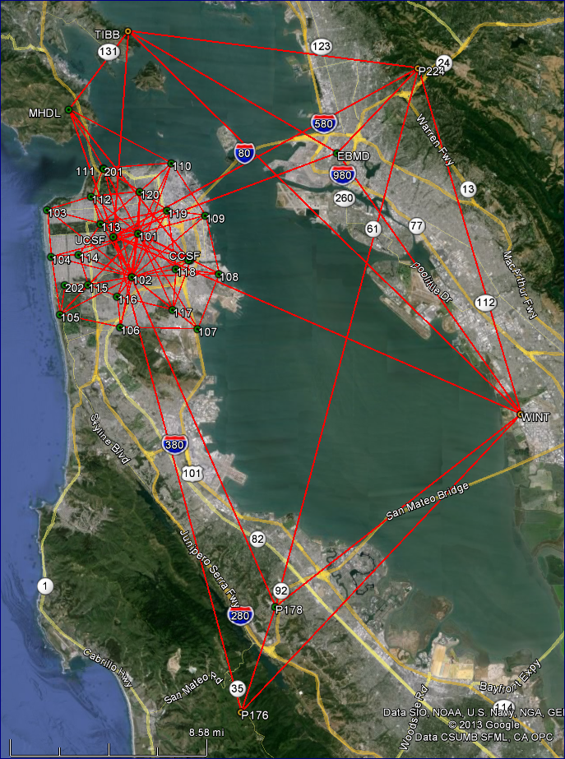

This document serves as a summary report of the City and County of San Francisco (CCSF) 2013 “B” Order Control Survey. A Record of Survey will follow incorporating the content of this Report and containing detailed descriptions of the points. This survey established 20 permanent high precision control points in July 2013 referred to as the CCSF-2013 HPN. This network provides the framework for establishing a densification network to support general survey activities, GIS, and for measuring annual and episodic earth movements. The field surveys were planned and coordinated in a joint effort by CCSF, Michael McGee, PLS3945 and F3 & Associates, Inc. Michael McGee, PLS was responsible for the final processing of the observations, network adjustments, analysis and reports. The Global Navigation Satellite System (GNSS) was used to determine positions based on the North American Datum of 1983 (NAD83) and International GNSS Service 2008 Reference Frame (IGS08). The survey is referenced to four National Geodetic Survey (NGS) Continuously Operated Reference Stations (CORS) in the region.

CCSF Regional & High Precision Network

**PROJECT DATUMS, REFERENCE SYSTEM**

**Geometric Datums:** North American Datum of 1983 - NAD83(2011) Epoch 2010.00 realization and IGS08(2005) Epoch 2013.54 (July 17, 2013 average date of field survey)

**Reference Network:** The survey is referenced to four NGS CORS stations (see NGS Data Sheets in Appendix)

**Vertical Datum:** CCSF 2013 NAVD88 Vertical Datum. Note, this survey evaluated the use of GNSS technology for establishing accurate orthometric heights and modeled the orthometric height of UCSF.

**Reference Network:** CCSF 2013 Second Order Leveling Network

**Projections:** The plane coordinates published in the survey are in units of meters and feet, and in two projections. Coordinates are provided in the California State Plane Coordinate System (SPCS) Zone III and in a local custom coordinate system created by this survey and referred to as the City & County of San Francisco Coordinate System (CCSF-CS).

The CCSF-CS is a low distortion grid projection designed for CCSF to be a ground coordinate system. CCSF varies from sea level to approximately 1000 feet in elevation. To minimize the differences in ground and grid distances, the projection surface was positioned at the most common ground height in the County taken at an ellipsoid height of 44.50 meters (146.0 feet). The average geoid height is -32.6 meters (-107 feet) and the NAVD88 height of the projection surface is 77 meters (253 feet). At this height the combined scale factor is 1.0 and the distortion is zero. Changes in height will increase or decrease the scale 4.8 ppm for every 30.5 meters (100 foot). This coordinate system provides a grid scale distortion of less than 1:100,000 (10 ppm) in most parts of CCSF except for the higher elevations. At the Central Meridian, North coincides with Geodetic North referenced to the GRS80 ellipsoid, centered in the NAD83(2011) 2010.00 Epoch reference frame. The Convergence Angle varies +/- two minutes as shown in the Appendix in the Plane Coordinate List. The projection specifications (similar to an SPCS projection) for input in user’s software follow.

Projection: Transverse Mercator, Ellipsoid: GRS-80, Scale: 1.000007, Latitude of Origin: 37º45’00”,

Central Meridian: -122º27’00”, False Northing: 24000.0 meters, False Easting: 48000.0 meters.

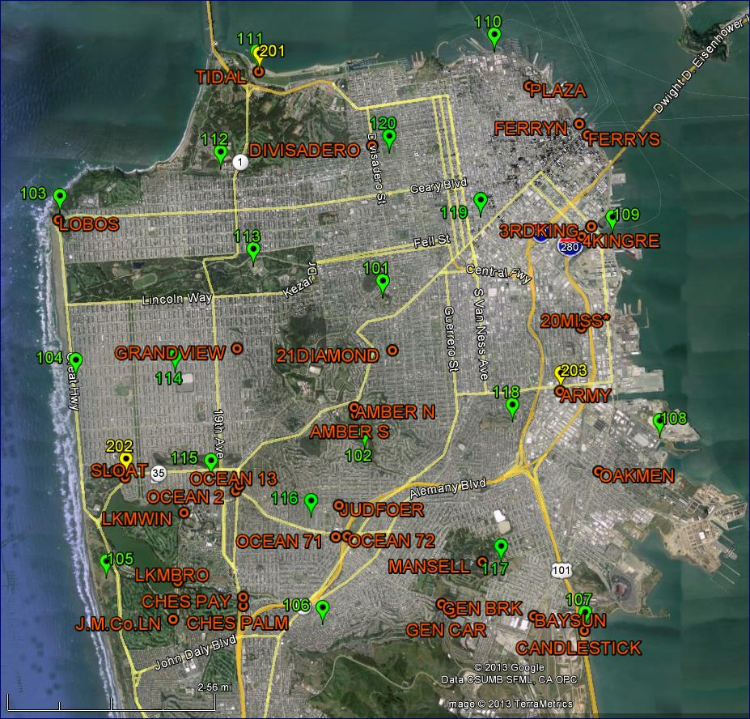The average Scale Factor, Height Reduction Factor and Convergence Angles listed below for the 20 HPN points provide a general comparison of the two projections.

*State Plane Coordinates Zone 3:*

*Combined Factor= 0.99992496 Convergence Angle= -1-11-34*

*San Francisco Coordinate System:*

*Combined Factor= 1.00000275*

*Convergence Angle= +0-00-04*

The specific values for each point are listed in the Appendix. Applying the average combined factors to a ground distance of 1000 foot equals 1000.003 feet in the CCSF-CS whereas in the SPCS it is 999.925 feet.

**Historical CCSF Control Network:**

A map on file with the CCSF titled “City and County of San Francisco Precise Horizontal Survey Control” dated May 2001 depicts a GPS Survey based on NAD83 (1991) 1991.35 Epoch with State Plane Coordinates published in 1991, 1998 and 1999. The 1999 Network (red) and 2013 HPN

Figure 1: 1999 Network Points and 2013 HPN Points

(green) are shown in Figure 1. This 2013 survey supersedes the 1991-1998-1999 surveys.

**Reference Network Velocity:** The North American Datum of 1983 is referenced to the North American Plate. CCSF sits on the Pacific Plate and is situated between the San Andreas Fault approximately 2 kilometers west of the southwest corner of CCSF and the Hayward Fault approximately 15 kilometers east of the northeast corner of CCSF. CCSF is moving 3.1 centimeters (0.10 feet) north and 2.1 centimeters (0.07 feet) west (N34°W 0.12 feet) per year relative to the North American Plate at the CGPS station UCSF as predicted by the NGS Horizontal Time Dependent Positioning (HTDP) model. Continued monitoring of the 2013 CCSF-HPN over time will develop a model of differential movements across the County.

**GEOMETRIC COORDINATES OF THE CONTROLLING CORS & CGPS STATIONS**

The following positions were constrained or derived in the Adjustments discussed hereafter.

**NAD83(2011) Epoch 2010.00 Positions per NGS Data Sheets (see Appendix)**

**ID Latitude(dms) W.Longitude(dms) EH(mtrs)_ NGS PID NAME_____**

**P176 37-28-18.36834 122-21-25.65069 434.339 DN7544 MILLSCREEKCN2007 GRP**

**P224 37-51-50.01427 122-13-08.56363 407.873 DH3881 SIBLEYVOLCCN2005 GRP**

**TIBB 37-53-27.13938 122-26-51.31741 -20.565 AI4507 TIBURON PENINSUL GRP**

**WINT 37-39-09.50579 122-08-25.99416 -28.259 AI4510 WINT_BARD_CN1991 GRP**

**NAD83(2011) Epoch 2013.54** per NAD83 velocities applied to Epoch 2010.00 Positions**

**ID Latitude(dms) W.Longitude(dms) EH(mtrs) Velocities (mm)____**

**P176 37-28-18.37230 122-21-25.65398 434.334 N 34.5 E-22.9 Up -1.3\***

**P224 37-51-50.01654 122-13-08.56563 407.869 N 19.8 E-13.8 Up -1.2**

**TIBB 37-53-27.14260 122-26-51.31998 -20.570 N 28.1 E-17.7 Up -1.4\***

**WINT 37-39-09.50872 122-08-25.99666 -28.264 N 25.5 E-17.3 Up -1.3\***

**NAD83(2011) Epoch 2013.54** Results of the Constrained Adjustment to the CORS positions listed above (see Adjustments & Analysis)

**CCSF 37-44-55.64324 122-24-01.58597 -15.950**

**EBMD 37-48-54.01939 122-17-01.65016 -15.403**

**MHDL 37-50-32.35159 122-29-39.55028 66.403**

**P178 37-32-04.25894 122-19-56.46131 129.572**

**UCSF 37-45-46.67553 122-27-29.29178 155.123**

**IGS08(2005) Epoch 2013.54 per IGS08 velocities applied to Epoch 2005 Positions**

**ID Latitude(dms) W.Longitude(dms) EH(mtrs) Velocities (mm)___**

**P176 37-28-18.38315 122-21-25.71047 433.810 N 21.3 E-36.2 Up 0.0\***

**P224 37-51-50.02759 122-13-08.62234 407.349 N 6.8 E-27.5 Up 0.1**

**TIBB 37-53-27.15354 122-26-51.37682 -21.084 N 14.8 E-31.4 Up 0.0\***

**WINT 37-39-09.51974 122-08-26.05320 -28.790 N 12.5 E-31.0 Up 0.0\***

*HTDP v3.2.3 velocities applied to CORS with less than 2.5 years of data

**Epoch of Survey

**NETWORK DESCRIPTION**

The CCSF GNSS Survey is comprised of a bay area Regional Network shown in Figure 2 and the CCSF High Precision Network shown in Figure 3. The Regional Network utilized four of the nearest operating NGS CORS stations (TIBB, P224, WINT and P176) as a basis for recovering IGS08(2005) Epoch 2013.54 and NAD83(2011) Epoch 2010.00 reference frames. Four CGPS stations (EBMD, MHDL, P178 and UCSF) were included to add strength and redundancy to the Regional Network. A private RTN station (CCSF) was included to establish a position relative to the CCSF-HPN. Three vectors or baselines were computed for each connection shown in Figure 2 using 24 hour observations staggered every other day during the field campaign.

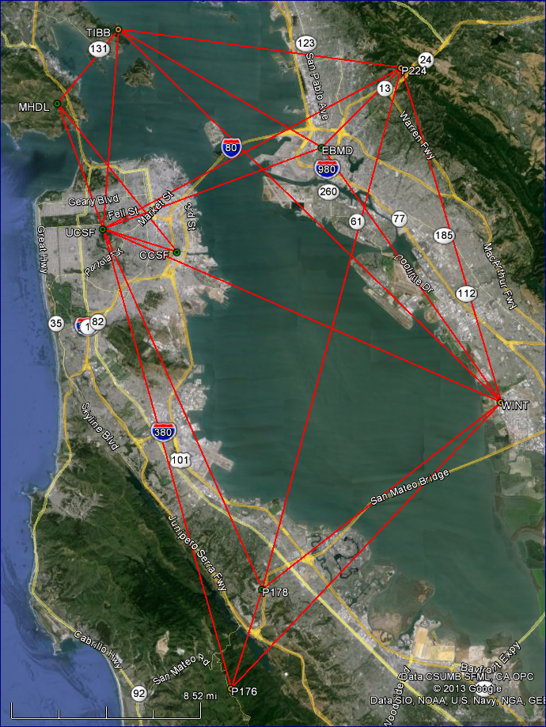

The 2013 CCSF-HPN (shown in Figure 3 and the Appendix) consists of 20 primary high precision points distributed across CCSF. The field campaign took place during the week of July 15-19, 2013 (average epoch 2013.54). Four crews operated four Leica GS15 GNSS receivers mounted on fixed-height poles. The receivers and fixed height poles were calibrated, and a validation survey of equipment and procedures took place prior to the field campaign.

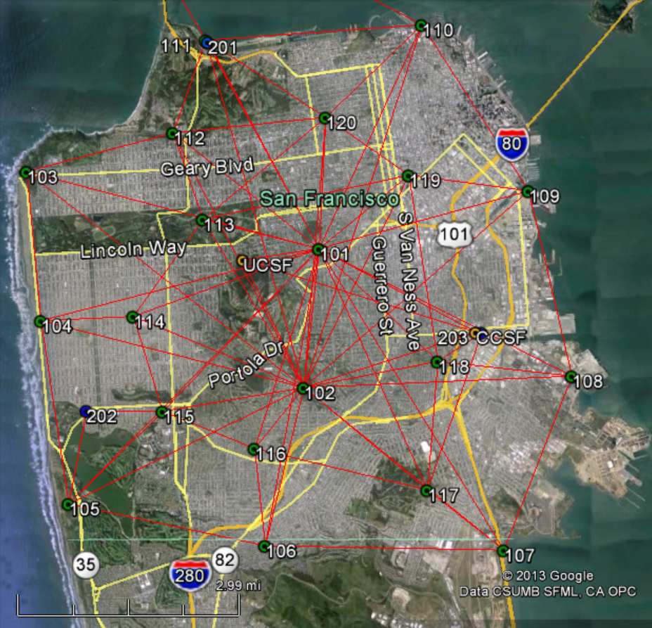The field campaign began on July 15 (Day1) with a base receiver occupying Point #101 (Corona Heights) for the day while the three crews occupied all points for 45 minutes each developing a radial network. On Day 2, a second radial network was developed with a base receiver occupying Point #102 (Marrietta Drive) as a base station while three crews occupied points for 45 minutes completing a second independent occupation of all points. On Day 3 and 4, a tandem operation was conducted with four crews working in unison collecting 45

Figure 2: Regional Network

minutes in common at their assigned points to complete the inner network connections between all adjacent points. At the end of the field campaign, all HPN points were occupied four or more times on different days and under different constellations.

In addition to the 20 primary HPN control points, three secondary points 201 (Tidal), 202 (Sloat) and 203 (Army) shown on the map of the 1999 GPS Survey on file with the CCSF Public Works referred to above were occupied twice with a fifth receiver for 15-30 minutes. These points are not part of the HPN. These points were included to determine the relationship between the 1999 CCSF reference frame and the 2013 NAD83(2011) 2010.00 Epoch reference frame established by this survey. Transformations from the 1999 reference frame to this 2013 survey are provided hereafter.

**Figure 3: City & County 2013 High Precision Network**

**ADJUSTMENTS & ANALYSIS**

Non-trivial vectors were processed from the observations and evaluated in the network adjustments listed below. The Regional Network connected nine stations including four CORS, four CGPS stations and one private continuously operated RTN station. The Regional Network contains 57 vectors averaging 20 kilometers in length with a maximum of 38 kilometers. The two-dimensional residuals averaged 0.002 meters with a standard deviation of 0.002 meters and a maximum of 0.010 meters. The absolute value of the vertical residuals averaged 0.002 meters with a standard deviation of 0.002 meters and a range of -0.007 to +0.008 meters. The 2013 CCSF-HPN connected 20 points, three secondary points, two CGPS stations and the private RTN station. The network contains 83 vectors averaging 4.3 kilometers in length with a maximum of 8.3 kilometers. The two-dimensional residuals averaged 0.003 meters with a standard deviation of 0.002 meters and a maximum of 0.010 meters. The absolute value of the vertical residuals averaged 0.003 meters with a standard deviation of 0.003 meters and a range of -0.009 to +0.016 meters.

Six network adjustments were processed to develop the geodetic and plane coordinates in two reference frames at different epochs. An overview of the adjustments follow with details thereafter.

Adjustment #1 and #2: Developed IGS08(2005) Epoch 2013.54 positions for referencing future secular and episodic movements of the region and CCSF. The IGS08(2005) positions of the four CORS were obtained from the NGS and moved to Epoch 2013.54 (epoch of this survey) using the NGS HTDP v3.2.3 velocity model. Adjustment #1 fixed WINT to evaluate the vector residuals and closures on the remaining three CORS. Adjustment #2 constrained the network to all four CORS to develop IGS08(2005) Epoch 2013.54 positions.

Adjustment #3 and #4: Developed NAD83(2011) Epoch 2013.54 positions for referencing the Regional Network. The NAD83(2011) Epoch 2010.00 positions of the four CORS were obtained from the NGS and moved to Epoch 2013.54 (epoch of this survey) using the HTDP v3.2.3 velocity model.

Adjustment #3 fixed WINT to evaluate the closures on the remaining three CORS.

Adjustment #4 constrained the network to all four CORS to develop NAD83(2011) Epoch 2013.54positions on the four CGPS stations.

Adjustment #5: Developed NAD83(2011) Epoch2010.00 positions for CCSF-HPN. The NAD83(2011) Epoch 2013.54 positions of stations UCSF, MHDL and CCSF, determined in Adjustment #4, were moved to Epoch 2010.00 using the HTDP v3.2.3 velocity model.

Adjustment #5 fixed the CGPS station UCSF at the Epoch 2010.00 position to evaluate the closures on MHDL and CCSF, and to develop positions on the 2013 CCSF-HPN.

Adjustment #6: Analyzed the Geoid 2012A Model utilizing a seven parameter conformal transformation with the scale parameter fixed at 1.0 to best fit the GNSS measurements to the NAVD88 Heights of the HPN points determined in the CCSF 2013 Second Order Leveling Network Survey (Report on file with CCSF). The adjustment demonstrates the application and expected results of using GNSS survey technology to develop orthometric heights in CCSF.

**IGS08(2005) Epoch 2013.54 Adjustments**

##### Adjustment 1: 3D Minimally Constrained Adjustment

The four nearest operating CORS form the basis for recovery of the IGS08 reference frame for this survey. IGS08(2005) Epoch positions and velocities were obtained from the NGS website for the CORS. The HTDP v3.2.3 model was used to update the CORS positions to the 2013.54 Epoch of this survey. Four CGPS stations and a private RTN station CCSF were included in the adjustments.

Station WINT was fixed in a Minimally Constrained Adjustment to determine preliminary latitude, longitude, ellipsoid heights at other stations and compute closures. The results follow with the coordinate differences (closures) from the IGS08 positions to the computed positions listed in meters below. The position for UCSF was determined from the mean of three 24 hours observations submitted to OPUS and used as a check on the results of this adjustment as shown.

**Coordinate Differences: IGS08 to Computed**

Station dN dE dZ_

**P176 0.007 -0.004 0.006**

**P224 0.012 0.003 0.002**

**TIBB 0.003 -0.001 -0.015**

**WINT 0.000 0.000 0.000 Fixed**

**UCSF 0.004 0.000 -0.018 OPUS IGS08 position to computed position**

**Note:** The differences between the published and computed positions range 0.000 to 0.012 meters in north,

-0.001 to +0.003 meters in east and -0.015 to +0.006 meters in the up direction. Network loop closures were less than a centimeter. The horizontal check on the OPUS position of UCSF is 0.004 meters.

##### Adjustment 2A: 3D Adjustment Solving for Transformation Parameters from WGS84 to IGS08

WGS84 is based on the IGS08 reference frame. In this adjustment the rotations and scale were solved to verify the consistency of the measured network in WGS84 and the IGS08 reference frame as represented by the positions of the CORS. The expectation are zero and the negligible results confirm the consistency of the two frames.

**WGS84 to IGS08(2005) Datum Transformation**

**Scale Factor 1.000000068467 = -0.068 PPM (1:14,700,000)**

**Rotation Around North Axis = -0.071 Sec**

**Rotation Around East Axis = -0.055 Sec**

**Rotation Around Vert. Axis = -0.015 Sec**

##### Adjustment 2B: 3D Constrained Adjustment

All four CORS were constrained for latitude, longitude and ellipsoid heights to develop IGS08(2005) 2013.54 Epoch positions on the network. The horizontal difference of 0.001 meters with the UCSF position obtained from the CORS Network utilizing the NGS OPUS Tool confirms the processes used in this survey.

**Coordinate Differences: IGS08(2005) 2013.54 Epoch to Computed**

Station dN dE dZ_

**UCSF -0.001 0.001 -0.014 OPUS IGS08 position**

Note: This Adjustment includes the CCSF-HPN. The results are listed in the Appendix Coordinate List.

**NAD83(2011) Epoch 2013.54 Adjustments**

##### Adjustment 3: 3D Minimally Constrained Adjustment

The four nearest operating CORS form the basis for recovery of the NAD83 reference frame for this survey. NAD83(2011) 2010.00 Epoch positions and velocities were obtained from the NGS website for the CORS. The HTDP v3.2.3 model was used to update the CORS to 2013.54 Epoch of this survey for this adjustment. Four CGPS stations and a private RTN station CCSF were included in the adjustment.

CORS station WINT was fixed in a Minimally Constrained Adjustment to determine preliminary latitude, longitude, ellipsoid heights at the three other CORS and compute closures. The results follow with the coordinate differences (closures) in meters from the NAD83(2011) 2013.54 Epoch to the computed positions listed below. The position for UCSF was determined by the SOPAC SECTOR utility and used as a check on the results of this adjustment as shown below.

**Coordinate Differences: NAD83(2011) 2013.54 Epoch to Computed**

Station dN dE dZ_

**P176 0.006 -0.004 0.005**

**P224 0.012 0.004 0.006**

**TIBB 0.004 -0.001 -0.010**

**WINT 0.000 0.000 0.000 Fixed**

**UCSF 0.009 -0.001 -0.004 Difference from SOPAC SECTOR position to computed**

**Note:** The differences between the published and computed positions range 0.000 to 0.012 meters in north,

-0.001 to +0.004 meters in east and -0.010 to +0.006 meters up direction. The position of UCSF as determined by SECTOR is referenced to the NAD83(2007) Adjustment Epoch 2013.54 whereas this adjustment is referenced to NAD83(2011) Adjustment Epoch 2013.54. The horizontal difference of 0.009 meters is indicative of the similarities of the two national adjustments.

##### Adjustment 4: 3D/Ellipsoid Heights – Constrained Adjustment

All four CORS were constrained for latitude, longitude and ellipsoid heights to develop NAD83(2011) Epoch 2013.54 positions. Notwithstanding the 2007 verses the 2011 Adjustments, the horizontal difference of 0.004 meters at UCSF indicates the compatibility of these results with those obtained from the SECTOR utility.

**Coordinate Differences: NAD83(2011) 2013.54 Epoch to Computed**

Station dN dE dZ_

**UCSF 0.004 -0.001 -0.004 Difference from SOPAC SECTOR position to computed**

**NAD83(2011) Epoch 2010.00 Adjustments**

##### Adjustment 5: 3D Minimally Constrained Adjustment of the CCSF-HPN

The NAD83(2011) 2010.00 Epoch positions at CCSF, MHDL and UCSF were derived by applying HTDP v3.2.3 velocities to the 2013.54 Epoch positions resulting from Adjustment #4. UCSF was fixed in a minimally constrained adjustment to determine latitude, longitude, ellipsoid heights at other stations and compute closures. The results follow with the coordinate differences (closures) in meters from the record positions to the computed positions listed below. The source for the record positions of 107, 201 and 202 are the NGS Data Sheets for the listed PID’s.

**Coordinate Differences: Record to Computed**

Station dN dE dZ_ NAD83 Epoch Source

**107 -0.034 0.007 -0.040 2010.00 NGS PID AB7679 = HPGND CA04GF**

**201 -0.029 0.002 -0.045 2010.00 NGS PID AE5209 = N TIDAL**

**202 -0.053 0.017 -0.031 2010.00 NGS PID AB7677 = HPGND CA04GE**

**203 0.537 -0.362 - 1991.35 1999 CCSF Control Survey-NAD83(1991)**

**CCSF -0.005 0.002 0.007 2010.00 HTDP Applied to Adj#4 Position**

**MHDL -0.003 0.003 -0.006 2010.00 HTDP Applied to Adj#4 Position**

**UCSF -0.000 -0.000 -0.000 2010.00 HTDP Applied to Adj#4 Position, Fixed**

Note: The differences at 203 reflect the difference between the 1991.35 and 2010.00 Epochs. The closures on the HTDP derived positions for CCSF and MHDL range 0.000 to -0.005 meters north, +0.002 to +0.003 meters east and -0.006 to +0.007 meters in the up direction and are at the noise level of the HTDP model; therefore, rather than distort the measured vectors in a constrained adjustment, the results of this adjustment were accepted to establish NAD83(2011) 2010.00 Epoch for the CCSF-HPN. Note: The Adjustment results are listed in the Appendix Coordinate List.

**Geoid Model Analysis: Adjustment of Ellipsoid Heights incorporating Geoid Heights to Determine NAVD88 Orthometric Heights:**

Two methods for determining NAVD88 Heights in a GPS/GNSS survey are discussed here. The first method approximates NAVD88 Heights by applying geoid heights to the measured ellipsoid heights using the equation H=h-N (Orthometric Height = Ellipsoid Height - Geoid Height). The accuracy of this method when applying the NGS Geoid 2012A to NAD83(2011) 2010.00 Epoch ellipsoid heights in San Francisco is approximately 0.06 meters as demonstrated below.

The second method takes advantage of the relative precision of modeled geoid heights. The Geoid 2012A Model was incorporated in a seven-parameter conformal transformation with the scale parameter fixed at 1.0 to best fit the NAVD88 Heights established on 20 HPN points determined by precise differential leveling (see the “Report on the City & County of San Francisco 2013 Second Order Leveling Network Survey and the 2013 NAVD88 Vertical Datum” on file with the County surveyor).

The NAD83(2011) 2010.00 Epoch Ellipsoid Height differences were combined with the Geoid 2012A Heights shown below in Column E and best fit to the leveled heights at the HPN points shown in Column B. This has the effect of best fitting the Geoid 2012A surface through the NAVD88 Heights at all 20 points. The results shown in Column A are the differences in meters from the leveled heights to the computed heights based on GNSS measurements. This is a best fit (least squares) solution therefore the mean of the differences is zero. The Standard Deviation of the differences is 0.004 meters (0.01’) and the range is -0.007 to +0.007 meters (+/-0.02’). The solved rotations are +0.213 seconds around the north and +0.243 seconds around the east axis. The rotations represent the tilts applied to the Geoid 2012A model to best fit the HPN orthometric heights which represent a geoid surface. The maximum effect of this tilt if unaccounted for is 1.6 mm per kilometer (0.008’ per mile) and is absorbed in a constrained adjustment. The orthometric height of UCSF was modeled in this adjustment.

As an additional check on the differential leveling to the highest HPN points, a constrained adjustment was processed fixing HPN points with orthometric heights less than 8 meters around the north and east shoreline. As a result, points 101 and 102 were found at -0.005 and +0.001 meters respectively. A one way shortest distance from the north shoreline would allow 0.006 meters for First Order Class I.



Geoid 2012A is a “hybrid” geoid model. Hybrid means it is based on GPS measured ellipsoid heights on a sampling of NAVD88 benchmarks over a large area to estimate the height of the NAD83(2011) zero ellipsoid surface above the NAVD88 zero surface. The measured NAD83(2011) 2010.00 Epoch Ellipsoid Heights (Column C) minus the leveled NAVD88 Heights (Column B) are the measured geoid heights at the HPN points (Column D) determined by this survey. The error in the Geoid 2012A hybrid model in San Francisco is 0.06 meters (Column F) being the difference in the computed Geoid 2012A Heights (Column E) and the measured geoid heights (Column D).

The recommended approach for determining orthometric heights with GNSS is to surround a project with three CCSF-HPN points (four preferred for redundancy) and compute a seven-parameter transformation that includes the Geoid 2012A Model to best fit the HPN 2013 NAVD88 Heights. The accuracy will depend on the combined accuracy of the NAVD88 heights of the HPN points, the GNSS measured ellipsoid height differences, the geoid heights and the effects of the tilt between the geoid model surface and the actual geoid surface. The largest source of error is usually in the measured ellipsoid heights. Following the specifications and procedures used in this survey, an orthometric height accuracy of 0.007 meters (0.02 feet) is obtainable.

As a matter of information, the NGS publishes the US Gravimetric Geoid 2012 (USGG2012) which is a gravimetric model referenced to the GRS80 ellipsoid, centered in the IGS08(2005.00) reference frame, and is the best geo-potential surface that approximates Mean Sea Level (MSL). USGG2012 is applied to WGS84 = IGS08 Ellipsoid Heights to obtain estimated heights referenced to global mean sea level (geoid). Utilizing the USGG2012 Model in a transformation to best fit the NAVD88 heights of the HPN points (described above) returned essentially the same results as the hybrid model; however, the rotations were +0.138 and +0.120 seconds around the north and east axis respectively, representing a negligible improvement. A new North American Vertical Datum is expected to be introduced in less than ten years. The origin or zero height is expected to be the geo-potential surface described above which is approximately 0.9 meters lower than the NAVD88 Datum and approximates the NGVD29 Datum.

### DATA COLLECTION, PROCESSING and EQUIPMENT

Five Leica GS15 geodetic GNSS receivers/antennas listed below were mounted on fixed height poles to collect, and store satellite signal data. The GS15 receivers tracked Navstar GPS and GLONASS satellites. Prior to initiating the field observations a calibration of the fixed height poles was conducted with a theodolite to verify their heights and plumb. The top of the poles were found to be plumb within 1 millimeter of the point. There were no equipment failures during the survey.

**Date of Field Surveys:** July 15 to July 19, 2013 (Average Date 2013.54)

**GNSS Survey Parameters:**

**Observations:** Static occupations collected GPS and GLONASS signal data at a 15 secondepoch rate for 45 minutes at all points with 8 hours at the base station setups for the radial observations on the first two days of the field campaign. Observations at the CORS and CGPS stations were GPS only for 24 hour at a 15 second epoch rate and downloaded from the Internet.

**Constellation:** 32 healthy US Navstar GPS satellites; 24 healthy Russian GLONASS satellites.

**Satellite Observations:** 12-21 satellites observed with a minimum of 6 GPS and 6 GLONASS at any time;

GDOP < 2; Elevation Mask for Data Collection set at 10° and post processed at 15°.

**Observables:** GPS L1 & L2 Carrier wave, GLONASS L1 & L2.

**Ephemeris:** Precise GPS and GLONASS for static post processing.

**Weather Conditions:** Generally overcast marine layer and mild temperatures.

**Space Weather:** Boulder K Index = 1-3 (gauges ionospheric activity on a scale of 0-9, <5 preferred).

The K Index was 1-2 on all days except on July 15 it was 3.

**Equipment:**

**GNSS Base Receiver** **Unit No.:** B, **Operator:** JTM, RA;

**Receiver Make & Model:** Leica GS15**; Antenna Make & Model**: Leica GS15

**Antenna Mount:** Fixed Ht. Pole B**; Antenna Height**: 1.800m

**GNSS Base Receiver** **Unit No.:** C, **Operator:** DPL;

**Receiver Make & Model:** Leica GS15**; Antenna Make & Model**: Leica GS15

**Antenna Mount:** Fixed Ht. Pole C**; Antenna Height**: 1.800m

**GNSS Base Receiver** **Unit No.:** D, **Operator:** GP;

**Receiver Make & Model:** Leica GS15**; Antenna Make & Model**: Leica GS15

**Antenna Mount:** Fixed Ht. Pole D**; Antenna Height**: 1.800m

**GNSS Base Receiver** **Unit No.:** E, **Operator:** AV;

**Receiver Make & Model:** Leica GS15**; Antenna Make & Model**: Leica GS15

**Antenna Mount:** Fixed Ht. Pole E**; Antenna Height**: 1.800m

**GNSS Base Receiver** **Unit No.:** F, **Operator:** MM, PC;

**Receiver Make & Model:** Leica GS15**; Antenna Make & Model**: Leica GS15

**Antenna Mount:** Fixed Ht. Pole F**; Antenna Height**: 1.800m

**CORS & CGPS National Geodetic Survey Antennas**

Note, absolute antenna models were used in the baseline processing and measurements were referenced to the monument not the antenna reference point (ARP).

**Stat. Antenna Radome**

**CCSF AX1202 GG NONE**

**EBMD LEIAR10 NONE**

**MHDL ASH700936C_M SNOW**

**P176 TRM29659.00   SCIT**

**P224 TRM29659.00   SCIT  
P178 TRM29659.00   SCIT**

**TIBB   ASH701945B_M  SCIT**

**UCSF ASH701945B_M   SCIT**

**WINT   ASH700936D_M CAFG <no model available, substituted “ASH700936D_M NONE”**

**Rinex Data, Antenna Models, Precise Ephemeris and Processing Software**: Rinex files for the CORS and CGPS were imported from the NGS and SOPAC. Absolute antenna models were imported from the NGS and the Precise Ephemeris was imported from the NGS for the GPS and IGS for the GLONASS constellations. The Precise Ephemeris was used for all static post-processing in IGS08. The Baseline Processing was performed in Leica Geomatics Office (LGO) v8.1. The Network Adjustments were performed in Starnet v7.2.

**ACCURACY: LOCAL & NETWORK**

This survey conforms to the requirements of Public Resources Code Section 8801 through 8819 and 8850 through 8880. This survey conforms to the intent of the FGCC “Geometric Geodetic Accuracy Standards and Specifications for Using GPS Positioning Techniques” (1989), the California Geodetic Control Committee (CGCC) “Specifications for High-Production GPS Surveying Techniques” (1993), and NOAA Technical Memorandum NOS NGS 58 "Guidelines for Establishing GPS-Derived Ellipsoid Heights”.

**Vector Residuals**: The number of vectors, two-dimensional vector residuals and the absolute value of the vertical residuals resulting from the minimally constrained adjustment are listed below in meters.

**Two Dimensional Residuals Vertical Residuals (absolute values)**

**No. Average Std.Dev. Maximum Average Std.Dev. Range**

**CCSF HPN 83 0.003 0.002 0.010 0.003 0.003 -0.009 to +0.016**

**Regional CORS 57 0.002 0.002 0.010 0.002 0.002 -0.007 to +0.008**

**Local Accuracy**: The local vector lengths, precisions, relative distance accuracy and relative vertical accuracy resulting from the minimally constrained adjustment at the 95% Level of Confidence are listed below in meters.

**Lengths PPM Precisions Relative Distance Error Rel.Vert. Error**

**Network Vary Average Vary Average Average Maximum Precision Average Maximum**

**CCSF HPN 1675-8291 4267 0.4-2.3 1.1 ppm 0.004 0.005 1:1,067,000 0.003 0.004**

**Regional 5322-37896 20224 0.1-0.6 0.2 ppm 0.003 0.003 1:6,741,000 0.003 0.004**

Following the criteria of the former FGCC classification system described in “Geometric Geodetic Accuracy Standards and Specifications for Using GPS Positioning Techniques” (1989), the maximum allowable relative error at the 95% confidence level is defined as s=√(e²+(0.1pd)²) where e is the base error, p is the ppm and d is the distance in kilometers. For the CCSF-HPN, B-Order is equivalent to √(.8²+(0.1·1·4.3)²) = 0.9 centimeters and A-Order is equivalent to √(.5²+(0.1·0.1·4.3)²) = 0.5 centimeters. Loop closures for the HPN vary between 1 ppm and 5 ppm. In conclusion, this survey exceeds a B-Order classification (1:1,000,000) under the former system and the Regional Network exceeds an A-Order classification (1:10,000,000).

**Network Accuracy**: The Standard Deviations (68% Level of Confidence) of the latitude, longitude and ellipsoid heights and the 95% Level of Confidence of the Horizontal Positions and Ellipsoid Heights for the Regional Network and the HPN are listed below in meters. This table allows users to calculate the propagated error for future surveys based on the HPN positions.

For P176, TIBB and WINT the NGS Data Sheets state “Formal positional accuracy estimates are not available for this CORS because its coordinates were determined in part using modeled velocities. Approximate one-sigma accuracies for latitude, longitude, and ellipsoid height can be obtained from the short-term time series”. Standard Deviations were only available for P224 (more than 2.5 years of data). Therefore, for consistency the positional accuracy estimates for all CORS stations (P176, P224, TIBB and WINT) were taken from the “Short Term Time Series” available at the NGS website. These one-sigma accuracy estimates were used for weighting the constrained adjustment to develop Network Accuracies.



These geodetic control data meet the 5-millimeter Local Accuracy Standard for the horizontal coordinate values, the 5-millimeter Local Accuracy Standard for the vertical coordinate values (heights), the 1-centimeter Network Accuracy Standard for the horizontal coordinate values, and the 1- centimeter Network Accuracy Standard for the vertical coordinate values (heights) at the 95-percent confidence level according to the reporting standard published by FGDC in "Geospatial Positioning Accuracy Standard, Part 2, Geodetic Control Networks", FGDC-Std-007, 2-1998.

**Transformation 1999 NAD83(1991.35 Epoch) SPCS > 2013 NAD83(2011) 2010.00 Epoch SPCS**

A map is on file with CCSF titled “City and County of San Francisco Precise Horizontal Survey Control” dated May 2001. The survey is based on NAD83 (1991) 1991.35 Epoch with adjustments published in 1991, 1998 and 1999. The 1999 State Plane Coordinate values shown on Sheets 4 & 5 of 7 for ARMY=203, CANDLESTICK=107, SLOAT=202 and TIDAL=201 were used to compute a four parameter conformal transformation to convert 1999 State Plane Coordinates in feet to this 2013 survey.

**INPUT COORDINATES (Feet)**

**1999 NAD83(1991)1991.35) SPCS 2013 NAD83(2011)2010.00 SPCS**

**PT# North(1) East(1) PT# North(2) East(2)**

**CANDLESTICK 2085128.546 6013911.480 107 2085130.260 6013910.280**

**TIDAL 2121772.462 5993470.060 201 2121774.233 5993468.889**

**SLOAT 2095678.561 5984226.406 202 2095680.395 5984225.175**

**ARMY 2100667.364 6012652.104 203 2100669.127 6012650.919**

**TRANSFORMATION SOLUTION RESIDUALS (Feet)**

**1999 2013 North East N.Azim & Dist**

**CANDLESTICK 107 -0.019 +0.018 138° 0.026**

**TIDAL 201 -0.031 -0.009 197° 0.032**

**SLOAT 202 +0.034 -0.011 342° 0.036**

**ARMY 203 +0.015 +0.003 11° 0.016**

**Root Mean Square of the North and East Residuals = 0.02**

**Scale Factor = 1.00000077 Standard Deviation = 0.00000078**

**Rotation = +0° 00' 00.4" Standard Deviation = 0° 00' 00.2"**

**TRANSFORMATION EQUATIONS: N2=A1*N1-A2*E1+A4 E2=A2*N1+A1*E1+A3**

**A1= 1.0000007745 A2= 0.0000019602 A3= -9.96251 A4= 11.90684**

The scale and rotation are negligible as expected between epochs of the same datum. The transformation primarily accounts for the north 1.7± feet and west 1.2± feet shift between the 1991.35 and the 2010.00 Epochs.

Utilize the Transformation Equations and constants listed to convert 1999 NAD83 (1991) Epoch 1991.35 SPCS to NAD83 (2011) Epoch 2010.00 SPCS in CCSF. The horizontal accuracy of the computed positions is estimated at 0.05 feet at the 95% level of confidence based on the residuals.

To convert the 1999 Survey NAD83(1991) 1991.35 Epoch SPCS in feet to NAD83(2011) 2010.00 Epoch of the City & County of San Francisco Coordinate System (CCSF-CS) in feet use the following transformation.

**Transformation: 1999 NAD83(1991) SPCS > NAD83(2011) 2010.00 Epoch CCSF-CS**

**INPUT COORDINATES (Feet)**

**1999 NAD83(1991)1991.35) SPCS 2010.00 CCSF-CS**

**PT# North(1) East(1) PT# North(2) East(2)**

**CANDLESTICK 2085128.546 6013911.480 107 62778.214 173801.613**

**TIDAL 2121772.462 5993470.060 201 98991.152 152599.533**

**SLOAT 2095678.561 5984226.406 202 72708.341 143900.815**

**ARMY 2100667.364 6012652.104 203 78288.679 172218.652**

**TRANSFORMATION SOLUTION RESIDUALS (Feet)**

**1999 2013 North East N.Azim & Dist**

**CANDLESTICK 107 -0.020 +0.016 140° 0.026**

**TIDAL 201 -0.032 -0.009 195° 0.033**

**SLOAT 202 +0.034 -0.012 340° 0.036**

**ARMY 203 +0.018 +0.004 13° 0.018**

**Root Mean Square of the North and East Residuals = 0.02**

**Scale Factor = 1.00007856 Standard Deviation = 0.00000079**

**Rotation = -1° 11' 37.4" Standard Deviation = 0° 00' 00.2"**

**TRANSFORMATION EQUATIONS N2=A1*N1-A2*E1+A4 E2=A2*N1+A1*E1+A3**

**A1= 0.9998615081 A2= -0.0208347280 A3= -5795833.91914 A4= -2147359.74825**

**RECOMMENDATION - SUMMARY**

As stated previously, CCSF sits between two major faults and it is expected that future re-surveys of the HPN will be conducted to determine secular and episodic movements within the area. If future surveys of the HPN follow the specifications and procedures adopted for this survey, the relative accuracy of measured shifts is expected to approach 5-6 millimeters at the 95% level of confidence. Statistically, this means the probability at the 95% level of confidence is that movement (signal) has occurred if the movement between two epochs is greater than the relative 95% error (noise). The differences in successive coordinates could be used to estimate movements but do not provide statistical information about the relative accuracies of movements. Measurements of temporal movements should be based on a rigorous simultaneous least squares adjustment of multiple redundant observations at two different epochs for each point to compute the movement and relative accuracy. The success of this process is predicated on the absolute recovery of the reference frame in this survey which is the IGS08(2005) 2013.54 Epoch based on the National Spatial Reference System (NSRS) CORS.



**APPENDIX**

**GLOSSARY**

CCSF City and County of San Francisco

CCSF-CS City and County of San Francisco Coordinate System

CGPS Continuously GPS Stations in California

CORS Continuously Operated Reference Stations in the National Spatial Reference System

FGCC Federal Geodetic Control Committee

FGDC Federal Geographic Data Committee

GIS Geographic Information System

GLONASS Globalnaya Navigatsionnaya Sputnikovaya Sistema (Russian GPS system)

GNSS Global Navigation Satellite System (GPS and GLONASS used in this survey)

GPS Global Positioning System

HPN High Precision Network

IGS08 International GNSS Service 2008 Reference Frame

K INDEX Space weather index ranging from 0-9, 1 being calm and 5 indicating a geomagnetic storm

LDP Low Distortion Projection

NAD83 North American Datum of 1983

NAVD88 North American Vertical Datum of 1988

NGS National Geodetic Survey

RTN Real-Time Network

SOPAC Scripps Orbit and Permanent Array Center

GDOP Geometric Dilution of Precision

L1 Carrier frequency @ 1575.42 MHz

L2 Carrier frequency @1227.60 MHz

NAVD29 North American Vertical Datum of 1929

GRS80 Geodetic Reference System of 1980

HTDP Horizontal Time-Dependent Positioning Program

PLS Professional Land Surveyor

NOAA National Oceanic and Atmospheric Administration

“2013 NAD83(2011) 2010.00 Epoch” represents the 2011 Adjustment of the North American Datum at Epoch 2010.00 established in CCSF in 2013

**NAD83 GEODETIC COORDINATE LIST**

**DATUM & REFERENCE FRAME: NAD83(2011) Epoch 2010.00**

**POINT N. LATITUDE W. LONGITUDE ELLIPSOID HT ELLIPSOID HT**

**‘ “ ‘ “ meters feet**

**101 37-45-54.52969 122-26-21.55646 118.188 387.754**

**102 37-44-16.70006 122-26-35.16804 138.344 453.883**

**103 37-46-48.82346 122-30-42.69982 13.592 44.594**

**104 37-45-03.75809 122-30-29.78795 -25.278 -82.931**

**105 37-42-54.76774 122-30-04.94280 23.607 77.449**

**106 37-42-25.30199 122-27-09.62037 77.575 254.510**

**107 37-42-22.15117 122-23-36.90485 -28.944 -94.959**

**108 37-44-24.76543 122-22-36.10746 -28.109 -92.221**

**109 37-46-35.29523 122-23-14.65957 -29.098 -95.467**

**110 37-48-32.30625 122-24-49.85029 -29.261 -96.002**

**111 37-48-21.50380 122-28-02.95054 -28.605 -93.848**

**112 37-47-16.23698 122-28-31.85392 21.692 71.168**

**113 37-46-15.21109 122-28-05.24080 42.159 138.316**

**114 37-45-06.84452 122-29-07.34048 66.915 219.538**

**115 37-43-59.89229 122-28-41.12920 28.692 94.135**

**116 37-43-33.80444 122-27-19.05616 57.292 187.966**

**117 37-43-04.59553 122-24-45.07281 84.526 277.316**

**118 37-44-35.20539 122-24-35.75058 45.947 150.745**

**119 37-46-46.37693 122-25-01.43682 -13.634 -44.731**

**120 37-47-27.12564 122-26-15.67191 53.304 174.881**

**CCSF 37-44-55.63969 122-24-01.58310 -15.938 -52.290**

**MHDL 37-50-32.34805 122-29-39.54740 66.402 217.855**

**UCSF 37-45-46.67199 122-27-29.28890 155.128 508.949**

**IGS08 GEODETIC COORDINATE LIST**

**DATUM & REFERENCE FRAME: IGS08(2005) Epoch 2013.54**

**POINT N. LATITUDE W. LONGITUDE ELLIPSOID HT**

**‘ “ ‘ “ meters**

**101 37-45-54.54414 122-26-21.61608 117.665**

**102 37-44-16.71449 122-26-35.22764 137.821**

**103 37-46-48.83787 122-30-42.75949 13.072**

**104 37-45-03.77249 122-30-29.84759 -25.798**

**105 37-42-54.78214 122-30-05.00241 23.085**

**106 37-42-25.31641 122-27-09.67995 77.053**

**107 37-42-22.16562 122-23-36.96440 -29.467**

**108 37-44-24.77990 122-22-36.16703 -28.633**

**109 37-46-35.30971 122-23-14.71918 -29.621**

**110 37-48-32.32072 122-24-49.90994 -29.783**

**111 37-48-21.51824 122-28-03.01021 -29.126**

**112 37-47-16.25141 122-28-31.91358 21.171**

**113 37-46-15.22552 122-28-05.30044 41.637**

**114 37-45-06.85894 122-29-07.40011 66.394**

**115 37-43-59.90670 122-28-41.18882 28.171**

**116 37-43-33.81887 122-27-19.11576 56.770**

**117 37-43-04.60998 122-24-45.13238 84.003**

**118 37-44-35.21984 122-24-35.81017 45.424**

**119 37-46-46.39139 122-25-01.49644 -14.157**

**120 37-47-27.14010 122-26-15.73155 52.782**

**CCSF 37-44-55.65415 122-24-01.64269 -16.461**

**EBMD 37-48-54.03039 122-17-01.70688 -15.922**

**MHDL 37-50-32.36248 122-29-39.60710 65.888**

**P176 37-28-18.38315 122-21-25.71047 433.810**

**P178 37-32-04.26983 122-19-56.51784 129.049**

**P224 37-51-50.02759 122-13-08.62234 407.349**

**TIBB 37-53-27.15354 122-26-51.37682 -21.084**

**UCSF 37-45-46.68643 122-27-29.34853 154.606**

**WINT 37-39-09.51974 122-08-26.05320 -28.790**

**PLANE COORDINATE LIST**

**California State Plane Coordinates Zone 3: NAD83(2011) 2010.00 Epoch and NAVD88 Heights per CCSF 2013 2nd Order Leveling Survey**

**POINT# STATE PLANE COORD. NAVD88 STATE PLANE COORD. NAVD88 Convergence ----- Factors -----**

**NORTH(m) EAST(m) HEIGHT(m) NORTH(ft) EAST(ft) HEIGHT(ft) Angle Scale x Ellipsoid = Combined**

**101 642177.520 1829147.188 150.799 2106877.414 6001127.064 494.746 -1-11-14.3 0.99992921 0.99998145 0.99991066**

**102 639169.103 1828751.516 170.991 2097007.299 5999828.933 560.993 -1-11-22.7 0.99992920 0.99997829 0.99990750**

**103 643985.863 1822793.428 46.352 2112810.286 5980281.439 152.073 -1-13-54.2 0.99992931 0.99999787 0.99992718**

**104 640740.769 1823039.791 7.550 2102163.674 5981089.714 24.770 -1-13-46.3 0.99992918 1.00000397 0.99993315**

**105 636752.037 1823562.786 56.489 2089077.308 5982805.572 185.331 -1-13-31.1 0.99992937 0.99999630 0.99992567**

**106 635753.146 1827836.561 110.302 2085800.113 5996827.116 361.882 -1-11-43.8 0.99992947 0.99998783 0.99991730**

**107 635548.974 1833043.520 3.698 2085130.260 6013910.280 12.133 -1-09-33.5 0.99992948 1.00000454 0.99993403**

**108 639298.261 1834608.138 4.484 2097431.045 6019043.533 14.711 -1-08-56.3 0.99992920 1.00000441 0.99993361**

**109 643340.513 1833745.648 3.461 2110693.000 6016213.847 11.355 -1-09-19.9 0.99992928 1.00000457 0.99993384**

**110 646994.405 1831490.574 3.279 2122680.811 6008815.324 10.758 -1-10-18.2 0.99992969 1.00000459 0.99993428**

**111 646759.384 1826761.484 4.000 2121909.745 5993299.969 13.123 -1-12-16.4 0.99992964 1.00000449 0.99993412**

**112 644762.606 1826012.184 54.344 2115358.651 5990841.639 178.294 -1-12-34.1 0.99992938 0.99999660 0.99992598**

**113 642867.936 1826623.601 74.816 2109142.554 5992847.597 245.459 -1-12-17.8 0.99992924 0.99999338 0.99992262**

**114 640792.840 1825059.534 99.656 2102334.511 5987716.154 326.955 -1-12-55.8 0.99992918 0.99998950 0.99991868**

**115 638715.658 1825657.369 61.448 2095519.621 5989677.550 201.601 -1-12-39.8 0.99992923 0.99999550 0.99992472**

**116 637869.351 1827649.621 89.985 2092743.029 5996213.798 295.226 -1-11-49.5 0.99992927 0.99999101 0.99992028**

**117 636891.154 1831400.952 117.172 2089533.729 6008521.289 384.422 -1-10-15.3 0.99992935 0.99998674 0.99991608**

**118 639679.300 1831686.204 78.553 2098681.170 6009457.154 257.719 -1-10-09.5 0.99992919 0.99999279 0.99992198**

**119 643735.185 1831140.342 18.941 2111987.853 6007666.271 62.142 -1-10-25.3 0.99992930 1.00000214 0.99993144**

**120 645028.567 1829350.275 85.887 2116231.223 6001793.361 281.781 -1-11-10.7 0.99992942 0.99999164 0.99992106**

**201 646718.080 1826812.971 3.659 2121774.233 5993468.889 12.005 -1-12-15.1 0.99992963 1.00000454 0.99993417**

**202 638764.662 1823995.481 23.761 2095680.395 5984225.175 77.956 -1-13-21.4 0.99992923 1.00000142 0.99993065**

**203 640285.230 1832659.665 2100669.127 6012650.919 -1-09-45.5 0.99992918 1.00000434 0.99993352**

**CCSF 640292.109 1832535.278 2100691.693 6012242.824 -1-09-48.6 0.99992918 1.00000250 0.99993168**

**MHDL 650842.310 1824485.178 2135305.146 5985831.789 -1-13-15.5 0.99993044 0.99998958 0.99992002**

**UCSF 641969.844 1827484.810 187.77 2106196.063 5995673.081 616.04 -1-11-55.8 0.99992920 0.99997566 0.99990486**

**Average -1-11-33.7 0.99992936 0.99999560 0.99992496**

**CCSF Plane Coordinates: NAD83(2011) 2010.00 Epoch and NAVD88 Heights per CCSF 2013 2nd Order Leveling Survey**

**POINT# CCSF PLANE COORD. NAVD88 CCSF PLANE COORD. NAVD88 Convergence ----- Factors -----**

**NORTH(m) EAST(m) HEIGHT(m) NORTH(ft) EAST(ft) HEIGHT(ft) Angle Scale x Ellipsoid = Combined**

**101 25681.275 48940.932 150.799 84255.983 160567.041 494.746 0-00-23.5 1.00000701 0.99998145 0.99998847**

**102 22665.032 48608.002 170.991 74360.193 159474.752 560.993 0-00-15.2 1.00000700 0.99997829 0.99998530**

**103 27356.975 42550.378 46.352 89753.676 139600.697 152.073 -0-02-16.4 1.00000737 0.99999787 1.00000523**

**104 24117.466 42864.322 7.550 79125.385 140630.698 24.770 -0-02-08.4 1.00000732 1.00000397 1.00001129**

**105 20140.186 43470.358 56.489 66076.592 142618.999 185.331 -0-01-53.1 1.00000725 0.99999630 1.00000355**

**106 19230.486 47764.351 110.302 63092.021 156706.874 361.882 -0-00-05.9 1.00000700 0.99998783 0.99999483**

**107 19134.838 52974.838 3.698 62778.214 173801.613 12.133 0-02-04.2 1.00000730 1.00000454 1.00001185**

**108 22916.205 54461.117 4.484 75184.248 178677.849 14.711 0-02-41.5 1.00000751 1.00000441 1.00001192**

**109 26939.924 53514.519 3.461 88385.400 175572.218 11.355 0-02-18.0 1.00000737 1.00000457 1.00001194**

**110 30546.317 51183.622 3.279 100217.376 167924.933 10.758 0-01-19.8 1.00000712 1.00000459 1.00001172**

**111 30212.789 46460.090 4.000 99123.126 152427.813 13.123 -0-00-38.6 1.00000703 1.00000449 1.00001152**

**112 28200.678 45752.500 54.344 92521.723 150106.327 178.294 -0-00-56.3 1.00000706 0.99999660 1.00000366**

**113 26319.011 46403.311 74.816 86348.290 152241.529 245.459 -0-00-40.0 1.00000703 0.99999338 1.00000042**

**114 24211.614 44882.700 99.656 79434.271 147252.657 326.955 -0-01-18.0 1.00000712 0.99998950 0.99999662**

**115 22147.178 45523.733 61.448 72661.199 149355.781 201.601 -0-01-01.9 1.00000708 0.99999550 1.00000257**

**116 21342.501 47533.342 89.985 70021.189 155948.974 295.226 -0-00-11.7 1.00000700 0.99999101 0.99999801**

**117 20442.606 51304.532 117.172 67068.783 168321.620 384.422 0-01-22.5 1.00000713 0.99998674 0.99999387**

**118 23236.307 51531.650 78.553 76234.451 169066.754 257.719 0-01-28.3 1.00000715 0.99999279 0.99999994**

**119 27280.254 50901.352 18.941 89501.966 166998.851 62.142 0-01-12.6 1.00000710 1.00000214 1.00000924**

**120 28536.156 49084.584 85.887 93622.371 161038.340 281.781 0-00-27.1 1.00000701 0.99999164 0.99999865**

**201 30172.563 46512.431 3.659 98991.152 152599.533 12.005 -0-00-37.3 1.00000703 1.00000454 1.00001157**

**202 22161.547 43861.056 23.761 72708.341 143900.815 77.956 -0-01-43.4 1.00000721 1.00000142 1.00000863**

**203 23862.437 52492.350 78288.679 172218.652 0-01-52.3 1.00000725 1.00000434 1.00001159**

**CCSF 23866.723 52367.837 78302.739 171810.144 0-01-49.2 1.00000723 1.00000250 1.00000974**

**MHDL 34247.715 44099.030 112361.043 144681.568 -0-01-37.9 1.00000719 0.99998958 0.99999677**

**UCSF 25438.989 47283.113 187.77 83461.083 155128.014 616.04 -0-00-17.9 1.00000701 0.99997566 0.99998266**

**Average 0-00-04.1 1.00000715 0.99999560 1.00000275**

**Projection Specifications:**

**Projection: Transverse Mercator, Ellipsoid: GRS-80, Scale: 1.000007, Latitude of Origin: 37º45’00”,**

**Central Meridian: -122º27’00”, False Northing: 24000.0 meters, False Easting: 48000.0 meters.**

**City & County of San Francisco Regional Network & High Precision Network (north up)**



**City & County of San Francisco High Precision Network**

**(north up)**



**NGS STATION DESCRIPTIONS** - **CORS NGS Reference Data for P176, P224, TIBB & WINT**

CORS Coordinates, HTDP Solutions for NAD83(2011) 2010.00 to 2013.54, and NGS Data Sheets (retrieved at the time of this survey)and [short-term time series](http://www.ngs.noaa.gov/cgi-cors/CorsSidebarSelect.prl?site=P176&option=Time%20Series%20(short-term))graphs

**P176**

**______________________________________________________________________________**

**MILLSCREEKCN2007 (P176), CALIFORNIA**

**| PID = DN7542 |**

**| IGS08 VELOCITY |**

**| Predicted with HTDP_3.1.2 Apr 2012. |**

**| VX = -0.0237 m/yr northward = 0.0213 m/yr |**

**| VY = 0.0303 m/yr eastward = -0.0362 m/yr |**

**| VZ = 0.0169 m/yr upward = 0.0000 m/yr |**

**| |**

**| NAD_83 (2011) VELOCITY |**

**| Transformed from IGS08 velocity in Apr 2012. |**

**| VX = -0.0074 m/yr northward = 0.0344 m/yr |**

**| VY = 0.0307 m/yr eastward = -0.0227 m/yr |**

**| VZ = 0.0265 m/yr upward = -0.0013 m/yr |**

**|_____________________________________________________________________________|**

**| |**

**| Monument: MILLSCREEKCN2007 GRP |**

**| ------------------------------ |**

**| PID = DN7544 |**

**| IGS08 POSITION (EPOCH 2005.0) |**

**| Computed in Apr 2012 using 29 days of data. |**

**| X = -2712719.288 m latitude = 37 28 18.37726 N |**

**| Y = -4281638.058 m longitude = 122 21 25.69787 W |**

**| Z = 3859341.975 m ellipsoid height = 433.810 m |**

**| |**

**| NAD_83 (2011) POSITION (EPOCH 2010.0) |**

**| Transformed from IGS08 (epoch 2005.0) position in Apr 2012. |**

**| X = -2712718.623 m latitude = 37 28 18.36834 N |**

**| Y = -4281639.174 m longitude = 122 21 25.65069 W |**

**| Z = 3859342.078 m ellipsoid height = 434.339 m |**

**| |**

**\* The position & velocity were revised in Apr 2012.**

**______________________________________________________________________________**

**HTDP (version 3.2.3) OUTPUT**

**HTDP UPDATED POSITIONS IN NAD_83(2011/CORS96/2007)**

**FROM 1-01-2010 TO 7-17-2013 (month-day-year)**

**FROM 2010.000 TO 2013.541 (decimal years)**

**OLD COORDINATE NEW COORDINATE VELOCITY DISPLACEMENT**

**P176**

**LATITUDE 37 28 18.36834 N 37 28 18.37230 N 34.53 mm/yr 0.122 m north**

**LONGITUDE 122 21 25.65069 W 122 21 25.65398 W -22.87 mm/yr -0.081 m east**

**ELLIP. HT. 434.339 434.334 -1.35 mm/yr -0.005 m up**

**X -2712718.623 -2712718.650 -7.50 mm/yr -0.027 m**

**Y -4281639.174 -4281639.065 30.89 mm/yr 0.109 m**

**Z 3859342.078 3859342.172 26.58 mm/yr 0.094 m**

**______________________________________________________________________________**

**DN7544 NGS Data Sheet \*\*\*\*\*\*\*\*\*\*\*\*\*\*\*\*\*\*\*\*\*\*\*\*\*\*\*\*\*\*\*\*\*\*\*\*\*\*\*\*\*\*\*\*\*\*\*\*\*\*\*\*\*\*\*\*\*\*\*\*\*\*\*\*\*\*\***

**DN7544 CORS - This is a GPS Continuously Operating Reference Station.**

**DN7544 DESIGNATION - MILLSCREEKCN2007 GRP**

**DN7544 CORS_ID - P176**

**DN7544 PID - DN7544**

**DN7544 STATE/COUNTY- CA/SAN MATEO**

**DN7544 COUNTRY - US**

**DN7544 USGS QUAD - WOODSIDE (1997)**

**DN7544 *CURRENT SURVEY CONTROL**

**DN7544 ______________________________________________________________________**

**DN7544* NAD 83(2011) POSITION- 37 28 18.36834(N) 122 21 25.65069(W) ADJUSTED**

**DN7544* NAD 83(2011) ELLIP HT- 434.339 (meters) (04/??/12) ADJUSTED**

**DN7544* NAD 83(2011) EPOCH - 2010.00**

**DN7544\*** [**NAVD 88**](http://www.ngs.noaa.gov/datums/vertical/VerticalDatums.shtml#NAVD88) **ORTHO HEIGHT - **(meters) **(feet)**

**DN7544 ______________________________________________________________________**

**DN7544 NAD 83(2011) X - -2,712,718.623 (meters) COMP**

**DN7544 NAD 83(2011) Y - -4,281,639.174 (meters) COMP**

**DN7544 NAD 83(2011) Z - 3,859,342.078 (meters) COMP**

**DN7544 LAPLACE CORR - 5.29 (seconds) DEFLEC12A**

**DN7544 GEOID HEIGHT - -32.59 (meters) GEOID12A**

**DN7544 HORZ ORDER - SPECIAL (CORS)**

**DN7544 ELLP ORDER - SPECIAL (CORS)**

**DN7544**

**DN7544.Formal positional accuracy estimates are not available for this CORS**

**DN7544.because its coordinates were determined in part using modeled**

**DN7544.velocities. Approximate one-sigma accuracies for latitude, longitude,**

**DN7544.and ellipsoid height can be obtained from the** [**short-term time series**](http://www.ngs.noaa.gov/cgi-cors/CorsSidebarSelect.prl?site=P176&option=Time%20Series%20(short-term))**.**

**DN7544.Additional information regarding modeled velocities is available on**

**DN7544.the** [**CORS Coordinates**](http://www.ngs.noaa.gov/CORS/coords.shtml) **and** [**Multi-Year CORS Solution FAQ**](http://www.ngs.noaa.gov/CORS/coord_info/myear_FAQ.shtml) **web pages.**

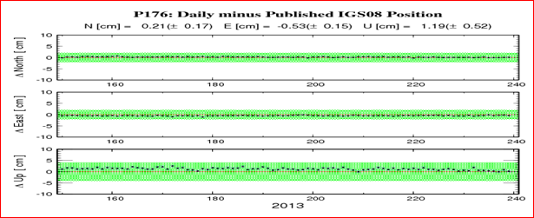

**DN7544**

**DN7544.The horizontal coordinates were established by GPS observations**

**DN7544.and adjusted by the National Geodetic Survey in April 2012.**

**DN7544**

**DN7544.NAD 83(2011) refers to NAD 83 coordinates where the reference**

**DN7544.frame has been affixed to the stable North American Tectonic Plate.**

**DN7544**

**DN7544.The horizontal coordinates are valid at the epoch date displayed above**

**DN7544.which is a decimal equivalence of Year/Month/Day.**

**DN7544**

**DN7544.The XYZ, and position/ellipsoidal ht. are equivalent.**

**DN7544**

**DN7544.The Laplace correction was computed from DEFLEC12A derived deflections.**

**DN7544**

**DN7544.The ellipsoidal height was determined by GPS observations**

**DN7544.and is referenced to NAD 83.**

**DN7544**

**DN7544. The following values were computed from the NAD 83(2011) position.**

**DN7544**

**DN7544; North East Units Scale Factor Converg.**

**DN7544;SPC CA 3 - 609,477.407 1,835,741.550 MT 0.99994099 -1 08 13.2**

**DN7544;SPC CA 3 - 1,999,593.79 6,022,762.07 sFT 0.99994099 -1 08 13.2**

**DN7544;UTM 10 - 4,147,403.346 556,845.451 MT 0.99963980 +0 23 28.0**

**DN7544**

**DN7544! - Elev Factor x Scale Factor = Combined Factor**

**DN7544!SPC CA 3 - 0.99993185 x 0.99994099 = 0.99987284**

**DN7544!UTM 10 - 0.99993185 x 0.99963980 = 0.99957167**

**DN7544**

**DN7544 SUPERSEDED SURVEY CONTROL**

**DN7544**

**DN7544 NAD 83(CORS)- 37 28 18.35942(N) 122 21 25.64286(W) AD(2002.00) A**

**DN7544 ELLIP H (04/??/12) 434.346 (m) GP(2002.00) 4 1**

**DN7544**

**DN7544.Superseded values are not recommended for survey control.**

**DN7544**

**DN7544.NGS no longer adjusts projects to the NAD 27 or NGVD 29 datums.**

**DN7544.**[**See file dsdata.txt**](http://www.ngs.noaa.gov/cgi-bin/ds_lookup.prl?Item=HOW_SUP_DET) **to determine how the superseded data were derived.**

**DN7544**

**DN7544_U.S. NATIONAL GRID SPATIAL ADDRESS: 10SEG5684547403(NAD 83)**

**DN7544**

**DN7544_STAMPING: UNKNOWN**

**DN7544 STATION DESCRIPTION**

**DN7544'THIS MONUMENT IS ASSOCIATED WITH CORS SITE 'P176'**

**DN7544'LATEST INFORMATION INCLUDING POSITIONS AND VELOCITIES**

**DN7544'ARE AVAILABLE IN THE COORDINATE AND LOG FILES ACCESSIBLE**

**DN7544'BY ANONYMOUS FTP OR THE WORLDWIDE WEB.**

**DN7544' ftp://cors.ngs.noaa.gov/cors/README.txt**

**DN7544' ftp://cors.ngs.noaa.gov/cors/coord/coord_08**

**DN7544' ftp://cors.ngs.noaa.gov/cors/station_log**

**DN7544' http://geodesy.noaa.gov/CORS**

**P224**

**______________________________________________________________________________**

**SIBLEYVOLCCN2005 (P224), CALIFORNIA**

**| IGS08 VELOCITY |**

**| Computed in Aug 2011 using data through gpswk 1631. |**

**| VX = -0.0211 m/yr northward = 0.0068 m/yr |**

**| VY = 0.0181 m/yr eastward = -0.0275 m/yr |**

**| VZ = 0.0054 m/yr upward = 0.0001 m/yr |**

**| NAD_83 (2011) VELOCITY |**

**| Transformed from IGS08 velocity in Aug 2011. |**

**| VX = -0.0047 m/yr northward = 0.0198 m/yr |**

**| VY = 0.0185 m/yr eastward = -0.0138 m/yr |**

**| VZ = 0.0149 m/yr upward = -0.0012 m/yr |**

**|_____________________________________________________________________________|**

**| Monument: SIBLEYVOLCCN2005 GRP |**

**| ------------------------------ |**

**| IGS08 POSITION (EPOCH 2005.0) |**

**| Computed in Aug 2011 using data through gpswk 1631. |**

**| X = -2688201.251 m latitude = 37 51 50.02572 N |**

**| Y = -4265643.690 m longitude = 122 13 08.61274 W |**

**| Z = 3893778.570 m ellipsoid height = 407.348 m |**

**| |**

**| NAD_83 (2011) POSITION (EPOCH 2010.0) |**

**| Transformed from IGS08 (epoch 2005.0) position in Aug 2011. |**

**| X = -2688200.572 m latitude = 37 51 50.01427 N |**

**| Y = -4265644.864 m longitude = 122 13 08.56363 W |**

**| Z = 3893778.614 m ellipsoid height = 407.873 m |**

**\* The position & velocity were revised in Aug 2011.**

**______________________________________________________________________________**

**HTDP (version 3.2.3) OUTPUT**

**UPDATED POSITIONS IN NAD_83(2011/CORS96/2007)**

**FROM 1-01-2010 TO 7-17-2013 (month-day-year)**

**FROM 2010.000 TO 2013.541 (decimal years)**

**OLD COORDINATE NEW COORDINATE VELOCITY DISPLACEMENT**

**P224**

**LATITUDE 37 51 50.01427 N 37 51 50.01666 N 20.82 mm/yr 0.074 m north**

**LONGITUDE 122 13 8.56363 W 122 13 8.56557 W -13.38 mm/yr -0.047 m east**

**ELLIP. HT. 407.873 407.868 -1.36 mm/yr -0.005 m up**

**X -2688200.572 -2688200.586 -3.94 mm/yr -0.014 m**

**Y -4265644.864 -4265644.797 18.85 mm/yr 0.067 m**

**Z 3893778.613 3893778.669 15.60 mm/yr 0.055 m**

**Used HTDP and the CORS velocities to compute the 2013.54 Epoch below**

**OLD COORDINATE NEW COORDINATE VELOCITY DISPLACEMENT**

**P224**

**LATITUDE 37 51 50.01427 N 37 51 50.01654 N 19.80 mm/yr 0.070 m north**

**LONGITUDE 122 13 8.56363 W 122 13 8.56563 W -13.80 mm/yr -0.049 m east**

**ELLIP. HT. 407.873 407.869 -1.20 mm/yr -0.004 m up**

**X -2688200.572 -2688200.589 -4.69 mm/yr -0.017 m**

**Y -4265644.864 -4265644.799 18.44 mm/yr 0.065 m**

**Z 3893778.613 3893778.666 14.89 mm/yr 0.053 m**

**______________________________________________________________________________**

**DH3881 NGS Data Sheet \*\*\*\*\*\*\*\*\*\*\*\*\*\*\*\*\*\*\*\*\*\*\*\*\*\*\*\*\*\*\*\*\*\*\*\*\*\*\*\*\*\*\*\*\*\*\*\*\*\*\*\*\*\*\*\*\*\*\*\*\*\*\*\*\*\*\*\*\*\***

**DH3881 CORS - This is a GPS Continuously Operating Reference Station.**

**DH3881 DESIGNATION - SIBLEYVOLCCN2005 GRP**

**DH3881 CORS_ID - P224**

**DH3881 PID - DH3881**

**DH3881 STATE/COUNTY- CA/CONTRA COSTA**

**DH3881 COUNTRY - US**

**DH3881 USGS QUAD - OAKLAND EAST (1997)**

**DH3881 *CURRENT SURVEY CONTROL**

**DH3881 ______________________________________________________________________**

**DH3881* NAD 83(2011) POSITION- 37 51 50.01427(N) 122 13 08.56363(W) ADJUSTED**

**DH3881* NAD 83(2011) ELLIP HT- 407.873 (meters) (08/??/11) ADJUSTED**

**DH3881* NAD 83(2011) EPOCH - 2010.00**

**DH3881\*** [**NAVD 88**](http://www.ngs.noaa.gov/datums/vertical/VerticalDatums.shtml#NAVD88) **ORTHO HEIGHT - **(meters) **(feet)**

**DH3881 ______________________________________________________________________**

**DH3881 NAD 83(2011) X - -2,688,200.572 (meters) COMP**

**DH3881 NAD 83(2011) Y - -4,265,644.864 (meters) COMP**

**DH3881 NAD 83(2011) Z - 3,893,778.614 (meters) COMP**

**Laplace CORR - 2.51 (seconds) DEFLEC12A**

**DH3881 GEOID HEIGHT - -32.17 (meters) GEOID12A**

**DH3881 HORZ ORDER - SPECIAL (CORS)**

**DH3881 ELLP ORDER - SPECIAL (CORS)**

**DH3881**

**DH3881 FGDC Geospatial Positioning Accuracy Standards (95% confidence, cm)**

**DH3881 Type Horiz Ellip Dist(km)**

**DH3881 -------------------------------------------------------------------**

**DH3881 NETWORK 2.02 6.62**

**DH3881 -------------------------------------------------------------------**

**DH3881 NOTE: Click** [**here**](http://www.ngs.noaa.gov/cgi-bin/lna_ret.prl?PID=DH3881) **for information on individual local accuracy**

**DH3881 values and other accuracy information.**

**DH3881 \*\*\*\*\*\*\*\*\*\*\*\*\*\*\*\*\*\*\*\*\*\*\*\*\*\*\*\*\*\*\*\*\*\*\*\*\*\*\*\*\*\*\*\*\*\*\*\*\*\*\*\*\*\*\*\*\*\*\*\*\*\*\*\*\*\*\*\***

**DH3881 ACCURACIES - Complete network and local accuracy information.**

**DH3881 CORS - This is a GPS Continuously Operating Reference Station.**

**DH3881 DESIGNATION - SIBLEYVOLCCN2005 GRP**

**DH3881 PID - DH3881**

**DH3881**

**DH3881 Statistical Information, in cm, for point DH3881 follows.**

**DH3881**

**DH3881 Note that Horz and Ellip values are the official 95%**

**DH3881 [FGDC accuracy standards.](http://www.fgdc.gov/standards/projects/FGDC-standards-projects/accuracy/part2/chapter2) The values of StdN, StdE and Stdh are the**

**DH3881 standard deviations (one sigma) of the coordinates (NETWORK) or**

**DH3881 of the difference in the coordinates (LOCAL) in Latitude, Longitude**

**DH3881 and Ellipsoid Height. The value CorrNE is the correlation**

**DH3881 coefficient between the latitude and longitude components of either**

**DH3881 the coordinate (NETWORK) or coordinate difference (LOCAL).**

**DH3881**

**DH3881 Type/PID Horz Ellip Dist(km) StdN StdE Stdh CorrNE**

**DH3881 -------------------------------------------------------------------**

**DH3881 NETWORK 2.02 6.62 0.00 0.91 0.71 3.38 +0.04283161**

**DH3881 -------------------------------------------------------------------**

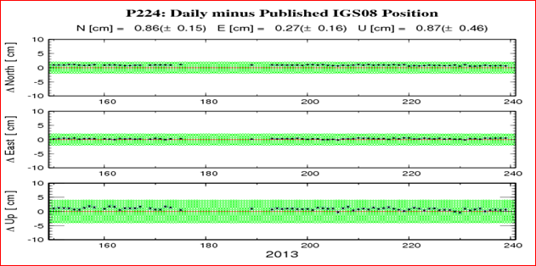

**DH3881**

**DH3881.The horizontal coordinates were established by GPS observations**

**DH3881.and adjusted by the National Geodetic Survey in August 2011.**

**DH3881**

**DH3881.NAD 83(2011) refers to NAD 83 coordinates where the reference**

**DH3881.frame has been affixed to the stable North American Tectonic Plate.**

**DH3881**

**DH3881.The horizontal coordinates are valid at the epoch date displayed above**

**DH3881.which is a decimal equivalence of Year/Month/Day.**

**DH3881**

**DH3881.The XYZ, and position/ellipsoidal ht. are equivalent.**

**DH3881**

**DH3881.The Laplace correction was computed from DEFLEC12A derived deflections.**

**DH3881**

**DH3881.The ellipsoidal height was determined by GPS observations**

**DH3881.and is referenced to NAD 83.**

**DH3881**

**DH3881. The following values were computed from the NAD 83(2011) position.**

**DH3881**

**DH3881; North East Units Scale Factor Converg.**

**DH3881;SPC CA 3 - 652,755.675 1,848,752.302 MT 0.99993111 -1 03 08.8**

**DH3881;SPC CA 3 - 2,141,582.58 6,065,448.18 sFT 0.99993111 -1 03 08.8**

**DH3881;UTM 10 - 4,191,001.178 568,692.783 MT 0.99965812 +0 28 45.7**

**DH3881**

**DH3881! - Elev Factor x Scale Factor = Combined Factor**

**DH3881!SPC CA 3 - 0.99993600 x 0.99993111 = 0.99986712**

**DH3881!UTM 10 - 0.99993600 x 0.99965812 = 0.99959414**

**DH3881**

**DH3881 SUPERSEDED SURVEY CONTROL**

**DH3881**

**DH3881 NAD 83(CORS)- 37 51 50.00906(N) 122 13 08.55850(W) AD(2002.00) A**

**DH3881 ELLIP H (06/??/05) 407.864 (m) GP(2002.00) 4 1**

**DH3881**

**DH3881.Superseded values are not recommended for survey control.**

**DH3881**

**DH3881.NGS no longer adjusts projects to the NAD 27 or NGVD 29 datums.**

**DH3881.**[**See file dsdata.txt**](http://www.ngs.noaa.gov/cgi-bin/ds_lookup.prl?Item=HOW_SUP_DET) **to determine how the superseded data were derived.**

**DH3881**

**DH3881_U.S. NATIONAL GRID SPATIAL ADDRESS: 10SEG6869291001(NAD 83)**

**DH3881**

**DH3881_STAMPING: UNKNOWN**

**DH3881**

**DH3881 STATION DESCRIPTION**

**DH3881**

**DH3881'THIS MONUMENT IS ASSOCIATED WITH CORS SITE 'P224'**

**DH3881'LATEST INFORMATION INCLUDING POSITIONS AND VELOCITIES**

**DH3881'ARE AVAILABLE IN THE COORDINATE AND LOG FILES ACCESSIBLE**

**DH3881'BY ANONYMOUS FTP OR THE WORLDWIDE WEB.**

**DH3881' ftp://cors.ngs.noaa.gov/cors/README.txt**

**DH3881' ftp://cors.ngs.noaa.gov/cors/coord/coord_08**

**DH3881' ftp://cors.ngs.noaa.gov/cors/station_log**

**DH3881' http://geodesy.noaa.gov/CORS**

**TIBB**

**______________________________________________________________________________**

**TIBURON PENINSUL (TIBB), CALIFORNIA**

**| IGS08 VELOCITY |**

**| Predicted with HTDP_3.2.3 Dec 2012. |**

**| VX = -0.0216 m/yr northward = 0.0148 m/yr |**

**| VY = 0.0245 m/yr eastward = -0.0314 m/yr |**

**| VZ = 0.0117 m/yr upward = 0.0000 m/yr |**

**| |**

**| NAD_83 (2011) VELOCITY |**

**| Transformed from IGS08 velocity in Dec 2012. |**

**| VX = -0.0052 m/yr northward = 0.0280 m/yr |**

**| VY = 0.0249 m/yr eastward = -0.0177 m/yr |**

**| VZ = 0.0213 m/yr upward = -0.0013 m/yr |**

**|_____________________________________________________________________________|**

**| Monument: TIBURON PENINSUL GRP |**

**| ------------------------------ |**

**| PID = AI4507 |**

**| IGS08 POSITION (EPOCH 2005.0) |**

**| Computed in Dec 2012 using 13 days of data. |**

**| X = -2704026.807 m latitude = 37 53 27.14944 N |**

**| Y = -4253050.099 m longitude = 122 26 51.36586 W |**

**| Z = 3895879.226 m ellipsoid height = -21.084 m |**

**| |**

**| NAD_83 (2011) POSITION (EPOCH 2010.0) |**

**| Transformed from IGS08 (epoch 2005.0) position in Dec 2012. |**

**| X = -2704026.130 m latitude = 37 53 27.13938 N |**

**| Y = -4253051.240 m longitude = 122 26 51.31741 W |**

**| Z = 3895879.300 m ellipsoid height = -20.565 m |**

**| |**

**______________________________________________________________________________**

**HTDP (version 3.2.3) OUTPUT**

**UPDATED POSITIONS IN NAD_83(2011/CORS96/2007)**

**FROM 1-01-2010 TO 7-17-2013 (month-day-year)**

**FROM 2010.000 TO 2013.541 (decimal years)**

**OLD COORDINATE NEW COORDINATE VELOCITY DISPLACEMENT**

**TIBB**

**LATITUDE 37 53 27.13938 N 37 53 27.14260 N 28.06 mm/yr 0.099 m north**

**LONGITUDE 122 26 51.31741 W 122 26 51.31998 W -17.72 mm/yr -0.063 m east**

**ELLIP. HT. -20.565 -20.570 -1.36 mm/yr -0.005 m up**

**X -2704026.130 -2704026.148 -5.13 mm/yr -0.018 m**

**Y -4253051.240 -4253051.152 24.96 mm/yr 0.088 m**

**Z 3895879.300 3895879.376 21.31 mm/yr 0.075 m**

**______________________________________________________________________________**

**AI4507 NGS Data Sheet \*\*\*\*\*\*\*\*\*\*\*\*\*\*\*\*\*\*\*\*\*\*\*\*\*\*\*\*\*\*\*\*\*\*\*\*\*\*\*\*\*\*\*\*\*\*\*\*\*\*\*\*\*\*\*\*\*\*\*\*\*\*\*\*\*\*\***

**AI4507 CORS - This is a GPS Continuously Operating Reference Station.**

**AI4507 DESIGNATION - TIBURON PENINSUL GRP**

**AI4507 CORS_ID - TIBB**

**AI4507 PID - AI4507**

**AI4507 STATE/COUNTY- CA/MARIN**

**AI4507 COUNTRY - US**

**AI4507 USGS QUAD - SAN QUENTIN (1995)**

**AI4507 *CURRENT SURVEY CONTROL**

**AI4507 ______________________________________________________________________**

**AI4507* NAD 83(2011) POSITION- 37 53 27.13938(N) 122 26 51.31741(W) ADJUSTED**

**AI4507* NAD 83(2011) ELLIP HT- -20.565 (meters) (12/??/12) ADJUSTED**

**AI4507* NAD 83(2011) EPOCH - 2010.00**

**AI4507\*** [**NAVD 88**](http://www.ngs.noaa.gov/datums/vertical/VerticalDatums.shtml#NAVD88) **ORTHO HEIGHT - 11.8 (meters) 39. (feet) GPS OBS**

**AI4507 ______________________________________________________________________**

**AI4507 NAD 83(2011) X - -2,704,026.130 (meters) COMP**

**AI4507 NAD 83(2011) Y - -4,253,051.240 (meters) COMP**

**AI4507 NAD 83(2011) Z - 3,895,879.300 (meters) COMP**

**AI4507 LAPLACE CORR - 0.01 (seconds) DEFLEC12A**

**AI4507 GEOID HEIGHT - -32.38 (meters) GEOID12A**

**AI4507 HORZ ORDER - SPECIAL (CORS)**

**AI4507 ELLP ORDER - SPECIAL (CORS)**

**AI4507**

**AI4507.Formal positional accuracy estimates are not available for this CORS**

**AI4507.because its coordinates were determined in part using modeled**

**AI4507.velocities. Approximate one-sigma accuracies for latitude, longitude,**

**AI4507.and ellipsoid height can be obtained from the** [**short-term time series**](http://www.ngs.noaa.gov/cgi-cors/CorsSidebarSelect.prl?site=TIBB&option=Time%20Series%20(short-term))**.**

**AI4507.Additional information regarding modeled velocities is available on**

**AI4507.the** [**CORS Coordinates**](http://www.ngs.noaa.gov/CORS/coords.shtml) **and** [**Multi-Year CORS Solution FAQ**](http://www.ngs.noaa.gov/CORS/coord_info/myear_FAQ.shtml) **web pages.**

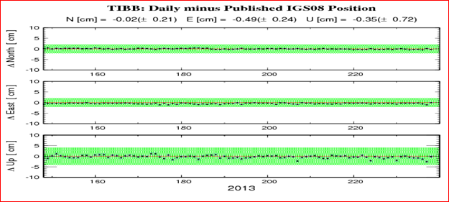

**AI4507**

**AI4507.The horizontal coordinates were established by GPS observations**

**AI4507.and adjusted by the National Geodetic Survey in December 2012.**

**AI4507**

**AI4507.NAD 83(2011) refers to NAD 83 coordinates where the reference**

**AI4507.frame has been affixed to the stable North American Tectonic Plate.**

**AI4507**

**AI4507.The horizontal coordinates are valid at the epoch date displayed above**

**AI4507.which is a decimal equivalence of Year/Month/Day.**

**AI4507**

**AI4507.The orthometric height was determined by GPS observations and a**

**AI4507.high-resolution geoid model.**

**AI4507**

**AI4507.The XYZ, and position/ellipsoidal ht. are equivalent.**

**AI4507**

**AI4507.The Laplace correction was computed from DEFLEC12A derived deflections.**

**AI4507**

**AI4507.The ellipsoidal height was determined by GPS observations**

**AI4507.and is referenced to NAD 83.**

**AI4507**

**AI4507. The following values were computed from the NAD 83(2011) position.**

**AI4507**

**AI4507; North East Units Scale Factor Converg.**

**AI4507;SPC CA 6 - 1,151,818.729 1,453,439.357 MT 1.00316890 -3 24 20.5**

**AI4507;SPC CA 6 - 3,778,925.28 4,768,492.29 sFT 1.00316890 -3 24 20.5**

**AI4507;UTM 10 - 4,193,850.969 548,572.252 MT 0.99962906 +0 20 21.4**

**AI4507**

**AI4507! - Elev Factor x Scale Factor = Combined Factor**

**AI4507!SPC CA 6 - 1.00000323 x 1.00316890 = 1.00317214**

**AI4507!UTM 10 - 1.00000323 x 0.99962906 = 0.99963229**

**AI4507**

**AI4507 SUPERSEDED SURVEY CONTROL**

**AI4507**

**AI4507 NAVD 88 (04/06/00) 11.7 (m) GEOID99 model used GPS OBS**

**AI4507**

**AI4507.Superseded values are not recommended for survey control.**

**AI4507**

**AI4507.NGS no longer adjusts projects to the NAD 27 or NGVD 29 datums.**

**AI4507.**[**See file dsdata.txt**](http://www.ngs.noaa.gov/cgi-bin/ds_lookup.prl?Item=HOW_SUP_DET) **to determine how the superseded data were derived.**

**AI4507**

**AI4507_U.S. NATIONAL GRID SPATIAL ADDRESS: 10SEG4857293850(NAD 83)**

**AI4507**

**AI4507_MARKER: Z = SEE DESCRIPTION**

**AI4507_SETTING: 0 = UNSPECIFIED SETTING**

**AI4507_STAMPING: UNKNOWN**

**AI4507_MARK LOGO: NONE**

**AI4507_MAGNETIC: N = NO MAGNETIC MATERIAL**

**AI4507_STABILITY: A = MOST RELIABLE AND EXPECTED TO HOLD**

**AI4507+STABILITY: POSITION/ELEVATION WELL**

**AI4507_SATELLITE: THE SITE LOCATION WAS REPORTED AS SUITABLE FOR**

**AI4507+SATELLITE: SATELLITE OBSERVATIONS - 1998**

**AI4507**

**AI4507 HISTORY - Date Condition Report By**

**AI4507 HISTORY - 1998 MONUMENTED NGS**

**AI4507**

**AI4507 STATION DESCRIPTION**

**AI4507'DESCRIBED BY NATIONAL GEODETIC SURVEY 1998**

**AI4507'THIS MONUMENT IS ASSOCIATED WITH CORS SITE 'TIBB'**

**AI4507'LATEST INFORMATION INCLUDING POSITIONS AND VELOCITIES**

**AI4507'ARE AVAILABLE IN THE COORDINATE AND LOG FILES ACCESSIBLE**

**AI4507'BY ANONYMOUS FTP OR THE WORLDWIDE WEB.**

**AI4507' ftp://cors.ngs.noaa.gov/cors/README.txt**

**AI4507' ftp://cors.ngs.noaa.gov/cors/coord/coord_08**

**AI4507' ftp://cors.ngs.noaa.gov/cors/station_log**

**AI4507' http://geodesy.noaa.gov/CORS**

**WINT**

**______________________________________________________________________________**

**WINT_BARD_CN1991 (WINT), CALIFORNIA**

**| IGS08 VELOCITY |**

**| Predicted with HTDP_3.2.3 Dec 2012. |**

**| VX = -0.0222 m/yr northward = 0.0125 m/yr |**

**| VY = 0.0229 m/yr eastward = -0.0310 m/yr |**

**| VZ = 0.0099 m/yr upward = 0.0000 m/yr |**

**| NAD_83 (2011) VELOCITY |**

**| Transformed from IGS08 velocity in Dec 2012. |**

**| VX = -0.0058 m/yr northward = 0.0255 m/yr |**

**| VY = 0.0233 m/yr eastward = -0.0173 m/yr |**

**| VZ = 0.0194 m/yr upward = -0.0013 m/yr |**

**| |**

**| Monument: WINT_BARD_CN1991 GRP |**

**| ------------------------------ |**

**| PID = AI4510 |**

**| IGS08 POSITION (EPOCH 2005.0) |**

**| Computed in Dec 2012 using 16 days of data. |**

**| X = -2689810.025 m latitude = 37 39 09.51629 N |**

**| Y = -4281187.927 m longitude = 122 08 26.04241 W |**

**| Z = 3874973.479 m ellipsoid height = -28.791 m |**

**| |**

**| NAD_83 (2011) POSITION (EPOCH 2010.0) |**

**| Transformed from IGS08 (epoch 2005.0) position in Dec 2012. |**

**| X = -2689809.352 m latitude = 37 39 09.50579 N |**

**| Y = -4281189.079 m longitude = 122 08 25.99416 W |**

**| Z = 3874973.548 m ellipsoid height = -28.259 m |**

**______________________________________________________________________________**

**HTDP (version 3.2.3) OUTPUT**

**UPDATED POSITIONS IN NAD_83(2011/CORS96/2007)**

**FROM 1-01-2010 TO 7-17-2013 (month-day-year)**

**FROM 2010.000 TO 2013.541 (decimal years)**

**OLD COORDINATE NEW COORDINATE VELOCITY DISPLACEMENT**

**WINT**

**LATITUDE 37 39 9.50579 N 37 39 9.50872 N 25.54 mm/yr 0.090 m north**

**LONGITUDE 122 08 25.99416 W 122 08 25.99666 W -17.33 mm/yr -0.061 m east**

**ELLIP. HT. -28.259 -28.264 -1.35 mm/yr -0.005 m up**

**X -2689809.352 -2689809.373 -5.80 mm/yr -0.021 m**

**Y -4281189.080 -4281188.997 23.34 mm/yr 0.083 m**

**Z 3874973.548 3874973.617 19.40 mm/yr 0.069 m**

**______________________________________________________________________________**

**AI4510 NGS Data Sheet \*\*\*\*\*\*\*\*\*\*\*\*\*\*\*\*\*\*\*\*\*\*\*\*\*\*\*\*\*\*\*\*\*\*\*\*\*\*\*\*\*\*\*\*\*\*\*\*\*\*\*\*\*\*\*\*\*\*\*\*\*\*\*\*\*\*\***

**AI4510 HT_MOD - This is a Height Modernization Survey Station.**

**AI4510 CORS - This is a GPS Continuously Operating Reference Station.**

**AI4510 DESIGNATION - WINT_BARD_CN1991 GRP**

**AI4510 CORS_ID - WINT**

**AI4510 PID - AI4510**

**AI4510 STATE/COUNTY- CA/ALAMEDA**

**AI4510 COUNTRY - US**

**AI4510 USGS QUAD - SAN LEANDRO (1993)**

**AI4510 *CURRENT SURVEY CONTROL**

**AI4510 ______________________________________________________________________**

**AI4510* NAD 83(2011) POSITION- 37 39 09.50579(N) 122 08 25.99416(W) ADJUSTED**

**AI4510* NAD 83(2011) ELLIP HT- -28.259 (meters) (12/??/12) ADJUSTED**

**AI4510* NAD 83(2011) EPOCH - 2010.00**

**AI4510\*** [**NAVD 88**](http://www.ngs.noaa.gov/datums/vertical/VerticalDatums.shtml#NAVD88) **ORTHO HEIGHT - 4.30 (meters) 14.1 (feet) GPS OBS**

**AI4510 ______________________________________________________________________**

**AI4510 NAVD 88 orthometric height was determined with geoid model GEOID03**

**AI4510 GEOID HEIGHT - -32.47 (meters) GEOID03**

**AI4510 GEOID HEIGHT - -32.52 (meters) GEOID12A**

**AI4510 NAD 83(2011) X - -2,689,809.352 (meters) COMP**

**AI4510 NAD 83(2011) Y - -4,281,189.079 (meters) COMP**

**AI4510 NAD 83(2011) Z - 3,874,973.548 (meters) COMP**

**AI4510 LAPLACE CORR - 2.63 (seconds) DEFLEC12A**

**AI4510 HORZ ORDER - SPECIAL (CORS)**

**AI4510 ELLP ORDER - SPECIAL (CORS)**

**AI4510**

**AI4510.Formal positional accuracy estimates are not available for this CORS**

**AI4510.because its coordinates were determined in part using modeled**

**AI4510.velocities. Approximate one-sigma accuracies for latitude, longitude,**

**AI4510.and ellipsoid height can be obtained from the** [**short-term time series**](http://www.ngs.noaa.gov/cgi-cors/CorsSidebarSelect.prl?site=WINT&option=Time%20Series%20(short-term))**.**

**AI4510.Additional information regarding modeled velocities is available on**

**AI4510.the** [**CORS Coordinates**](http://www.ngs.noaa.gov/CORS/coords.shtml) **and** [**Multi-Year CORS Solution FAQ**](http://www.ngs.noaa.gov/CORS/coord_info/myear_FAQ.shtml) **web pages.**

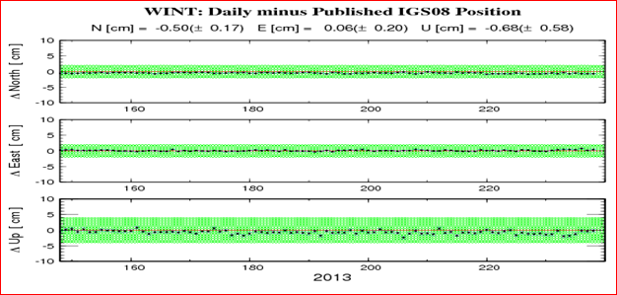

**AI4510.The horizontal coordinates were established by GPS observations**

**AI4510.and adjusted by the National Geodetic Survey in December 2012.**

**AI4510**

**AI4510.NAD 83(2011) refers to NAD 83 coordinates where the reference**

**AI4510.frame has been affixed to the stable North American Tectonic Plate.**

**AI4510**

**AI4510.The horizontal coordinates are valid at the epoch date displayed above**

**AI4510.which is a decimal equivalence of Year/Month/Day.**

**AI4510**

**AI4510.The orthometric height was determined by GPS observations and a**

**AI4510.high-resolution geoid model using precise GPS observation and**

**AI4510.processing techniques.**

**AI4510**

**AI4510.The XYZ, and position/ellipsoidal ht. are equivalent.**

**AI4510**

**AI4510.The Laplace correction was computed from DEFLEC12A derived deflections.**

**AI4510**

**AI4510.The ellipsoidal height was determined by GPS observations**

**AI4510.and is referenced to NAD 83.**

**AI4510**

**AI4510. The following values were computed from the NAD 83(2011) position.**

**AI4510**

**AI4510; North East Units Scale Factor Converg.**

**AI4510;SPC CA 6 - 1,123,770.181 1,478,989.373 MT 1.00283790 -3 14 13.1**

**AI4510;SPC CA 6 - 3,686,902.67 4,852,317.63 sFT 1.00283790 -3 14 13.1**

**AI4510;UTM 10 - 4,167,623.257 575,812.323 MT 0.99967079 +0 31 30.1**

**AI4510**

**AI4510! - Elev Factor x Scale Factor = Combined Factor**

**AI4510!SPC CA 6 - 1.00000443 x 1.00283790 = 1.00284235**

**AI4510!UTM 10 - 1.00000443 x 0.99967079 = 0.99967522**

**AI4510**

**AI4510 SUPERSEDED SURVEY CONTROL**

**AI4510 NAVD 88 (04/03/01) 4.2 (m) UNKNOWN model used GPS OBS**

**AI4510 NAVD 88 (04/06/00) 4.3 (m) GEOID99 model used GPS OBS**

**AI4510**

**AI4510.Superseded values are not recommended for survey control.**

**AI4510**

**AI4510.NGS no longer adjusts projects to the NAD 27 or NGVD 29 datums.**

**AI4510.**[**See file dsdata.txt**](http://www.ngs.noaa.gov/cgi-bin/ds_lookup.prl?Item=HOW_SUP_DET) **to determine how the superseded data were derived.**

**AI4510**

**AI4510_U.S. NATIONAL GRID SPATIAL ADDRESS: 10SEG7581267623(NAD 83)**

**AI4510_MARKER: Z = SEE DESCRIPTION**

**AI4510_SETTING: 0 = UNSPECIFIED SETTING**

**AI4510_STAMPING: UNKNOWN**

**AI4510_MARK LOGO: NONE**

**AI4510_MAGNETIC: N = NO MAGNETIC MATERIAL**

**AI4510_STABILITY: A = MOST RELIABLE AND EXPECTED TO HOLD**

**AI4510+STABILITY: POSITION/ELEVATION WELL**

**AI4510_SATELLITE: THE SITE LOCATION WAS REPORTED AS SUITABLE FOR**

**AI4510+SATELLITE: SATELLITE OBSERVATIONS - 1998**

**AI4510**

**AI4510 HISTORY - Date Condition Report By**

**AI4510 HISTORY - 1998 MONUMENTED NGS**

**AI4510 STATION DESCRIPTION**

**AI4510'DESCRIBED BY NATIONAL GEODETIC SURVEY 1998**

**AI4510'THIS MONUMENT IS ASSOCIATED WITH CORS SITE 'WINT'**

**AI4510'LATEST INFORMATION INCLUDING POSITIONS AND VELOCITIES**

**AI4510'ARE AVAILABLE IN THE COORDINATE AND LOG FILES ACCESSIBLE**

**AI4510'BY ANONYMOUS FTP OR THE WORLDWIDE WEB.**

**AI4510' ftp://cors.ngs.noaa.gov/cors/README.txt**

**AI4510' ftp://cors.ngs.noaa.gov/cors/coord/coord_08**

**AI4510' ftp://cors.ngs.noaa.gov/cors/station_log**

**AI4510' http://geodesy.noaa.gov/CORS**

**______________________________________________________________________________**