**Survey Report**

of the

**City & County of San Francisco 2013 NAVD88 Vertical Datum**

**Second Order Leveling Network Survey**

prepared by

**McGee Surveying Consulting and F3 & Associates, Inc.**

**PROJECT OVERVIEW:** The City & County of San Francisco (CCSF) performed a Second Order Leveling Survey between January and October 2013. The purpose was to recover the North American Vertical Datum of 1988 (NAVD88) and establish a vertical control reference network within the City and County henceforth known as the “CCSF 2013 NAVD88 Vertical Datum” shown in Figure 1. Heights resulting from this survey supersede previously published NAVD88 Heights on NGS benchmarks and the old CCSF Datum. The network will support the utilization of GNSS technology for establishing orthometric heights within the County.

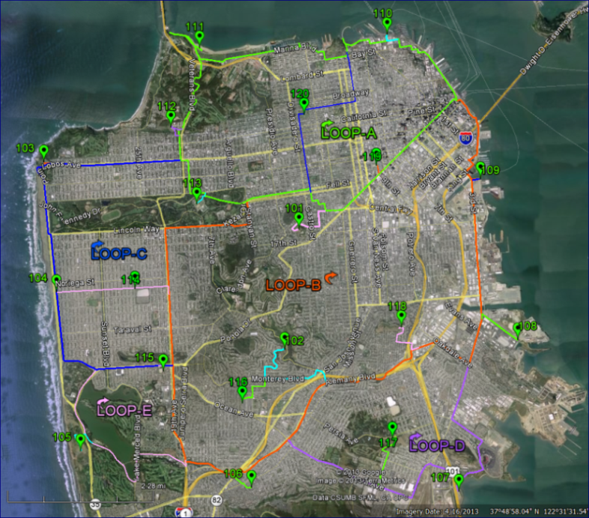**DATUM, REFERENCE SYSTEM and HISTORY:** Orthometric heights (elevations) published by this survey are based on the North American Vertical Datum of 1988 (NAVD 88) established by the National Geodetic Survey (NGS) as referenced by monuments in the National Spatial Reference System (NSRS). The analysis and recovery assessment of the NAVD88 Datum in the City and County is provided hereafter.

Circa 1989 the NGS performed First Order Class I leveling surveys along the northeast and north side of San Francisco and along Highway 1 (19th Street) from Highway 101 south. The survey was part of a national leveling effort to produce the NAVD88 Datum. The results were published in 1991 as the original national adjustment of NAVD88 which superseded the National Geodetic Vertical Datum of 1929 (NGVD29). NGVD29 differs by approximately +0.83 meters (2.7 feet) and varies approximately 0.80 to 0.86 meters in the City and County.

**Figure 1: Level Loops and High Precision Network Points**

**SAN FRANCISCO CITY DATUM STATEMENT**: Due to little or no maintenance of City & County of San Francisco benchmarks based on the old City of San Francisco Datum (CCSF Datum), it is difficult to determine a verifiable relationship to convert from the CCSF Datum to NAVD88. A “Precision Leveling Report” issued January 25, 2001 by Bureau of Construction Management (BCM) Chief Surveyor John Cory, stated “NAVD88 values varied from 11.319 ft. to 11.366 ft. higher than found Primary City Bench Marks. NGVD29 values varied from 8.586 ft. to 8.628 ft. higher than found Primary City Bench Marks.” The “Prime” benchmark monument, known as NGS HT0781 and referred to as BM990781 in this survey is described as a chiseled triangle in the top of the southeast end of the granite step to the entrance of the pumping station, located on the northwest corner of the intersection of Townsend Street and 2nd Street, in the City and County of San Francisco. The NAVD88 elevation of the “Prime” benchmark determined by BCM Chief Surveyor John Cory in his 2001 leveling efforts is identical to the height of 7.158 meters determined by the CCSF 2013 leveling effort. The City and County Surveyor has determined that the conversion from NAVD88 to the CCSF Datum, based on an analysis of the City’s “Prime” benchmark, henceforth shall be the “2013 NAVD88 Datum” height values minus 11.35 feet (3.460 meters) to obtain an elevation on the old “CCSF Datum”.

Conversion Constant: 2013 NAVD88 Datum - 11.35 feet = CCSF Datum

**EQUIPMENT, DATA COLLECTION & POST PROCESSING OF DATA:** The measurements were collected and recorded with a Leica DNA10 electronic digital level and 4.05 meter Leica GKNL4 fiberglass bar code rods. The Federal Geodetic Control Subcommittee (FGCS) Specifications and Procedures (ver. 4.1) for Second Order Class I Geodetic Leveling were merged with a detailed document titled “City & County of San Francisco 2013 NAVD 88 Vertical Datum Specification and Procedures” and used as the standard for this survey. The instrument was calibrated by the manufacturer prior to commencing the survey, the instrument was further calibrated with a collimation test each day prior to leveling, and the rods were checked and calibrated periodically during the survey. The field survey followed the backsite-foresite-foresite-backsite (BFFB) procedure and the instrument was set up at locations intended to balance the sights. Three measurements were averaged for each sighting taken in the sequence B-F-F-B, with two rods. The rods were moved forward in a leap frog manner. Michael McGee, PLS processed the measurements, analyzed network closures and residuals for blunders, computed final adjustments using Starnet v7.1 Software, and reported the results.

The field naming convention used for points in the leveling survey follows: NGS benchmarks have the four digit numerical portion of their Point ID (PID) preceded by “99”; thus, the field designation for NGS HT0687 is BM990687. The CCSF-HPN control points 101-120 are preceded by "88"; thus point 101 is BM88101. New benchmarks set in this survey begin with BM10001 and BM11001. Detailed descriptions and photos of benchmark monuments are on file with the City and County Surveyor’s Office.

**SURVEY NETWORK:** The vertical control network consists 115 kilometers (72 miles) of closed loops ranging 4-179 meters above sea level. The network is comprised of 22 color coded loops assigned letter designations of A through V shown in Figures 1 and 2. Five primary loops labeled A through E form the backbone network totaling 77.4 kilometers with 17 smaller loops totaling 37.5 kilometers. Approximately 670 new permanent benchmarks were established. All points (101-120) in the 2013 CCSF High Precision Network (CCSF-HPN) were included in the network (see the “Survey Report of the City and County of San Francisco 2013 High Precision Network” on file in the City and County Surveyor’s Office).

Thirty-five NGS benchmarks incorporated into this survey are shown with their NGS PID’s in Figure 2. The PID’s are color coded as follows: green indicates First Order Class I accuracy with a stability A or B, yellow indicates First Order Class I stability C or D, and orange indicates a VertCon benchmark that was translated from NGVD29 to NAVD88.

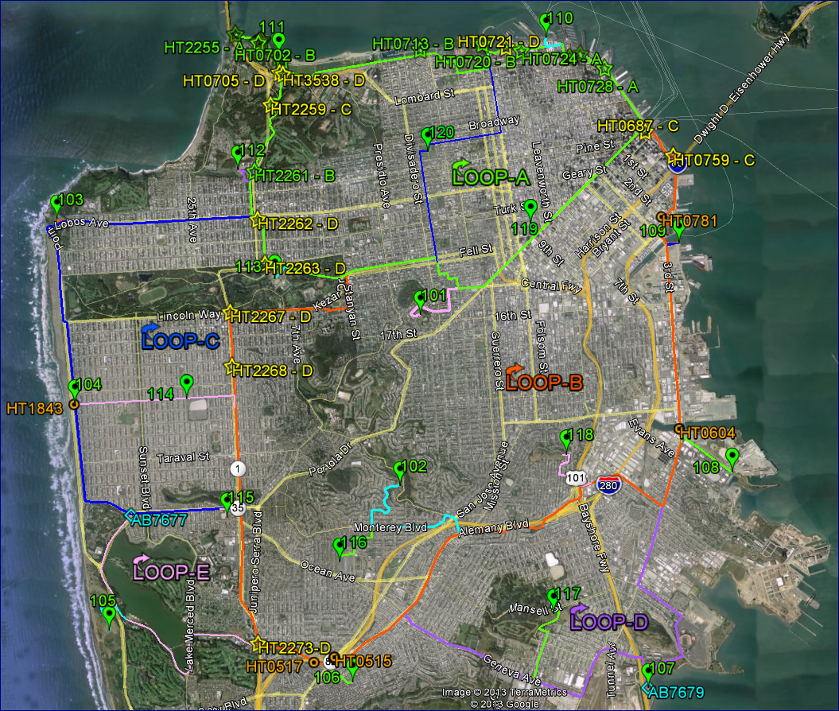

Figure 2: NGS Benchmarks and High Precision Network Points

The NGS classifies the probable stability of benchmarks on a scale of A-D, where A is considered the most stable. Benchmarks included in the national 1991 NAVD88 Adjustment with an accuracy classification of First Order Class I and a stability classification of A or B were deemed the best candidates for recovery of the NAVD88 Datum. All such candidates were searched for and 14 were recovered as noted hereafter. Adjusted First Order Class I benchmarks with a stability classification of C or D were also included when recovered along the leveling routes.

**PROJECT ADJUSTMENTS:** A minimally constrained adjustment was processed for each of the 22 loops listed here with their lengths in kilometers and closures in millimeters. The loops vary 0.5–25.3 kilometers with a total length of 115 kilometers. For comparison, the allowable closures in millimeters are listed for a 1st Order Class II Survey (4mm*√kilometers) and a 2nd Order Class I Survey (6mm*√kilometers). Twenty loops closed better than 1st Order Class II, Loop “V” met 1st Order Class II and Loop “S” met a 2nd Order Class II (8mm*√kilometers) classification.

All 22 loops were combined in a minimally constrained adjustment fixed at NGS benchmark HT2255. The NGS published height of HT2255 was found in agreement with the NAVD88 Datum as recovered by this survey based on a least squares analysis of 35 benchmarks discussed hereafter.

The combined adjustment residuals range -2.9 to +2.3 millimeters. The 95% Error of the heights resulting from this adjustment average 9 millimeters and range 1 to 12 millimeters relative to the fixed constraint at benchmark HT2255. Overall, the closure accuracies in this survey conformed to 2mm*√kilometers. The closure requirement for First Order Class I is 3mm*√kilometers.

**NAVD88 Recovery Analysis:** The following table lists the NGS benchmarks incorporated in this survey and shown in Figure 2. The “Status-Stability” column indicates the basis for the NAVD88 Heights. “Adjusted” indicates the height was derived from the 1991 national adjustment and “VertCon” indicates the height was derived by applying a translation to the legacy NGVD29 elevation. VertCon is an NGS program that estimates the vertical translation from NGVD29 to NAVD88 based on benchmarks common to both datums. The “Adjusted” benchmarks have an accuracy classification of First Order Class I with a stability classification grouped in the range of A-B or C-D.

After fixing HT2255, the differences in meters from the NGS published heights of the benchmarks to the heights determined by this survey are listed in the right three columns under “Difference Record to Measured Ht.” and analyzed below.



The mean of the differences for all 35 benchmarks in the “All BM’s” column is +0.001 meters with a standard deviation of 0.017 meters. The mean of the 25 “Adjusted” benchmarks in the “All Adj’d” column, after removing the -0.045 meter outlier at HT0713, is 0.000 meters with a standard deviation of 0.011 meters. After removing outliers greater than 0.02 meters at HT0713 and HT0692, the 12 “Adjusted” benchmarks with a stability of A or B in the “A-B Adj’d” column provide the most reliable recovery of NAVD88. The mean of the differences is 0.000 meters with a range of -0.012 to +0.014 meters and a standard deviation of 0.008 meters. At the 95% level of confidence the datum is recovered within 0.016 meters.

HT2255 was selected to reference the minimally constrained adjustment for the following reasons: it is classified as a stability “A” benchmark set in a bedrock formation, it agrees 0.001 to 0.002 meters with two nearby stability “B” benchmarks HT0698 and HT0700, and the difference with the record height in the above least squares analysis is zero.

**HISTORICAL CCSF LEVELING:** Between 1999 and 2002, CCSF conducted precise leveling surveys under the direction of BCM Chief Surveyor John Cory. These surveys ran along the Embarcadero to 3rd Street south to the County Line, north and south of Market Street and, Market Street westerly to 19th Street and southerly to Sloat Blvd. The 2002 surveys fixed NGS benchmark HT3541 at the recorded elevation of 5.601 meters which was found at 5.605 meters by this survey. Listed below are the 2002 era benchmarks recovered along the routes in this survey with the differences in meters from their 2002 heights to this survey.

***Fix table***



The shifts at BM10278 = T0064 of 0.028 meters and BM10468 = T-0121 of 0.044 meters are considered outliers. For the remaining 35 benchmarks, the shifts vary between -0.017 and +0.021 meters and average -0.001 meters with a standard deviation of 0.009 meters. A geo-analysis of the differences found no trends and indicate a consistency with the 1999-2002 surveys of +/- 0.02 meters.

**GPS SURVEYS:** At completion of the leveling survey, a precision GNSS survey observed CCSF-HPN points 101-120 (referred to as BM88101 to BM88120). These points provided a basis for assessing the use of GNSS/GPS technology to model orthometric heights (elevations) at the level of one centimeter (0.03’) or better within the County. GNSS measurements referenced to the leveled heights of the CCSF-HPN points provide a method for replacement of conventional differential leveling to determine NAVD88 Heights. See the “Survey Report of the City and County of San Francisco 2013 High Precision Network” for additional information.

**ACCURACY:**  Based on the adjustment residuals, the relative accuracy of the leveled heights of adjacent monuments is 0.001 meters and the absolute accuracy of the heights determined by this survey is dependent on the recovery of the NAVD88 Datum as described above.

Attachments: “City & County of San Francisco 2013 NAVD88 Vertical Datum - Specification and Procedures” and the NAVD88 Orthometric Height List

SURVEYOR'S STATEMENT: This report on the criteria and procedures used on the Leveling Survey was prepared by me on February 14, 2014 at the request of the Bruce R. Storrs, City and County Surveyor of San Francisco.

*_________________________*

Michael R. McGee, PLS 3945